**Dissemination report**

**Date:** *Feb 6, 2023*

**Venue:** *Discussion about the digitalization situation with the private sector in Thailand: Honeywell company*

**Organizing institution:** *ICO NIDA and EUBA*

**Description:**

*To understand digitalization in various sectors in Thailand and Southeast Asia, ICO NIDA and professor from EUBA arranged a visit to Honeywell Thailand to discuss over this issue. Honeywell is a Fortune 100 company where deliver industry solutions through Accelerating Digital Transformation. Lead Honeywell’s software products sales in the assigned region and/or to assigned customers, and deliver business results, including order-bookings, growth of sales revenue, and margin improvements. Develop and maintain expert sales knowledge for the Software Products that are part of the portfolio to be sold. Develop and maintain knowledge of the industries, the trends in the region. In this meeting, there are Professor Anetta Caplanova (EUBA), Dr. Wichit Sophitanontrat (Honeywell, Business Director – Enterprise Accounts) , assistant prof. Sid Suntrayuth, ( Dean of ICO NIDA), assistance prof. Marisa Laokulrach (vice dean of ICO NIDA), and associate prof. Aweewan Panyagometh (vice dean of ICO NIDA).*

**Photos:**

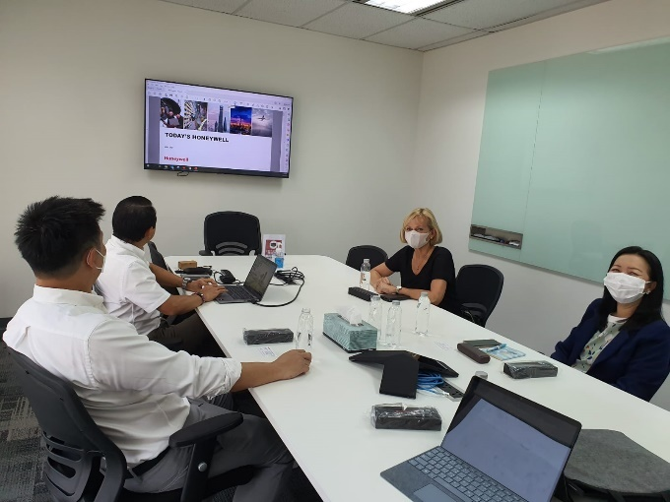

**Report prepared by:** *Aweewan Panyagometh, ICO NIDA*