Towards a cashless society: Examining the Impact of Digital Infrastructure on mPayment Transactions (A Cross-Region Analysis)

Nor Hazirah Mohamad Shukri
Universiti Teknologi MARA
Arshad Ayub Graduate Business School
Shah Alam, 40450
Malaysia
e-mail: nhazirahshukri@gmail.com
Nataša Kovač
University of Donja Gorica
Faculty of Applied Sciences
Podgorica, 81000
Montenegro
e-mail: natasa.kovac@udg.edu.me

Abstract
The worldwide financial environment has been completely transformed by the rise of financial technology, or fintech, which has greatly increased mobile payment (mPayment) transactions. This study investigates the relationship between digital infrastructure and mPayment transactions across countries through a quantitative analysis approach. Secondary data from central banks and relevant agencies are used to explore factors such as the access to electric, secure internet server, numbers of individual using internet, mobile cellular subscriptions, fixed broadband subscription, the automated teller machines (ATMs), and mobile data’s affordability. The study uses regression modelling and comparative analytic approaches to shed light on how digital infrastructure affects mPayment transactions, with a focus on a variety of EU-27 and Southeast Asian nations. The results show that Secure Internet Servers and internet penetration are key factors influencing mPayment transactions, provide guidance on how to encourage mPayment use, and leverage digitalization to drive socioeconomic progress towards a cashless society.

JEL classification: G02, G20
Keywords: electronic payment, digital infrastructure, e-readiness, cashless society

1. Introduction
The emergence of financial technology, or fintech, is transforming the landscape of the financial services industry by harnessing technological progress to provide enhanced transition platforms. The usage of technology like the internet and mobile networks have improved customer access and convenience with the use of smartphones. Organizations such as the World Bank have acknowledged the influence of fintech on economic growth and stability due to its capacity to increase revenue, simplify operations, and foster favorable attitudes inside startups and small and medium-sized businesses (Ngo & Nguyen, 2022). Furthermore, Bulkhairova et al. (2023) add that the growing use of fintech solutions drive a bright future for the companies that conduct technology-enabled financial transactions.
In order to enhance service delivery in the financial sector, the institutions are taking advantage of fintech innovation by applying new information and internet technologies (Ng & Kwok, 2017). Because of this, electronic payment (ePayment) has become more common and the traditional visits to physical financial institutions are declining (Najib et al., 2021). Developing countries are seeing a significant growth in mobile payments (Singh et al., 207; Singh et al., 2020) as electronic payment has become important (Capegemini, 2020). ). In addition, the pandemic has triggered a surge in digital payment usage and expedited development, especially in e-commerce (Xiao & Chorzempa, 2020). As reported by the Central Bank of Malaysia, the nation faces a surge of ePayment transactions in 2022, reaching 9.5 billion from 7.2 billion in 2021 (Yin, 2023).
Figures 1 and 2 show the rise in mobile point-of-sale (POS) payments between 2017 and 2023 in the 27 member states of the European Union (EU-27) and a few chosen Southeast Asian nations. With rises of over $70 billion and $20 billion, respectively, by 2023, Denmark and Sweden top the EU in terms of highly established mobile payment ecosystems. Other nations see steady development, including Germany, Austria, Belgium, and France. The post-2020 spike indicates that the adoption of mobile payments was expedited by the COVID-19 epidemic. With $7.58 billion by 2023, Singapore will top Southeast Asia, followed by Indonesia ($5.05 billion), both of which are driven by huge, tech-savvy populations and strong digital infrastructure. While Thailand, Lao PDR, and Myanmar show slower but consistent development, the Philippines, Malaysia, and Cambodia also show robust growth. Finally, Brunei Darussalam has little increase, a sign of low adoption.
According to earlier research on security infrastructure and mPayment, e-wallets and online payments have shown a sharp increase in popularity over the last ten years (Shaikh et al., 2023). Research like Santosa et al. (2021) examine how various generations plan to continue using digital payments, offering insights that can help managers create efficient marketing plans to increase the user base. On the other hand, Ligon et al. (2019) investigate the limited uptake of digital payment systems among small-scale retailers, highlighting the significance of digital literacy and accessible infrastructure. Mansour (2021) looks into how nations encouraged digital transactions during the COVID-19 pandemic, emphasising how financial status, the efficacy of governments, and the use of digital technology influenced the formulation of policy solutions.
Adeleye et al. (2020) highlight the importance of information and communication technology (ICT) in driving economic development where they found that trade, availability of mobile telephone, and fixed telephone subscriptions drives economic growth. Furthermore, Sanga and Aziakpono (2022) emphasize on how the growth of mobile phone subscription, number of ATMs, secure internet server has an impact on financial deepening in Africa. This proves the importance of digital infrastructure in financial systems.
Likewise, Kouladoum (2023) study on the inclusive growth in Sub-Saharan Africa focuses on the digital infrastructure development and found that mobile cellular subscriptions, fixed broadband, fixed phone, and internet usage significantly boosts inclusive growth. These findings highlight the role that digital infrastructure plays in promoting equitable growth and resource allocation.
Figure 1
Mobile POS Payments in EU-27 Countries
Source: Statista (2024)

Figure 2
Mobile POS Payments in Southeast Asia Countries

Source: Statista (2024)

Moreover, Putrevu and Mertzanis (2023) point out that the acceptance of digital payments may be hindered by the limited access to internet connectivity, low level of digital literacy, and a dearth of financial services in underdeveloped areas. These examples demonstrate the significance of digital infrastructure components in shaping the mobile payment. Digital infrastructure such as internet connections, secure payment gateways, mobile networks, and ATMs greatly influence the uptake and use of mobile payment solutions. Policymakers, financial institutions, and technology providers that wish to advance financial inclusion and digitalization must comprehend the factors that influence the adoption of mobile payments. The purpose of this research is to compare the factors that influence the adoption of mobile payments in Southeast Asia and the EU-27.
In order to pinpoint important factors that are unique to a certain region, this study used a thorough determinant framework together with longitudinal analysis. By generating insights that might direct future research and influence policy choices in both established and developing nations, these components came together to give a distinctive and significant contribution to the literature on mPayment uptake. Hence, the research objectives are
- To identify the determinants of mobile payment adoption in EU and Southeast Asian countries;
- To identify the differences between the determinants to bridge the digital gap and harness digitalization for socio-economic advancement towards a cashless society.
2. Literature Review
2.1 Mobile Payment Adoption
The global shift towards cashless payments is getting popular and significantly contribute to the adoption of digital payment methods (Tanha, 2024) including payment conducted through online banking or mobile apps (Ong & Chong, 2022). Businesses quickly implementing cashless payment for a streamline transaction, lower cost of managing the cash and increase the transaction speeds (Rahman et al. 2022). The COVID-19 pandemic has accelerated this trend led by the development in financial technology (Jesuthasan & Umakanth, 2021). Research highlights that mobile payment plays a crucial role in modern financial ecosystem by boosting financial inclusion and digitalization of economies (World Bank, 2021; Ong & Chong, 2022).
According to Liu et al. (2020), there has been a notable surge and market expected a significant market growth in usage of mobile payment services which including point-of-sale (POS) systems globally. Afaha (2019) also discussed the rising acceptance and value of POS transaction in electronic banking. In addition, Mahesh and Mahesh (2022) demonstrate the connection between digital payment systems and financial accessibility by integrating digital payment, Unified Payment Interface (UPI), and digital financial inclusion.
Behera (2023) highlighted initiatives by the Reserve Bank of India (RBI) to enhance payment and settlement systems, focusing on reducing transaction costs and improving digital transaction efficiency. Renukadevi and Hema (2022) explored buyer acceptance and perception of e-payments, stressing the importance of methods like mobile payments in digital transactions. Phonthanukitithaworn et al. (2016) examined mobile payment services in Thailand, highlighting the usability and convenience of electronic transactions and the importance of user experience in influencing payment behaviors. Ching and Hayashi (2010) studied the impact of payment card rewards programs on consumer payment choices, revealing the significant role of incentives in driving digital payment adoption.
Teoh et al. (2013) conducted an empirical analysis on factors affecting consumer perceptions of electronic payments, emphasizing the importance of customer trust, security, and convenience in shaping payment behaviors. Abdullah et al. (2020) explored factors influencing user acceptance of e-wallets in Malaysia, highlighting the shift towards a cashless society driven by digital payment technologies. This study underscored the transformation of traditional payment methods into digital environments, offering a wide range of electronic transaction options. Tee and Ong (2016) discussed the relationship between cashless payments and economic growth, emphasizing the convenience, safety, and efficiency of electronic transactions. Their study highlighted the increasing adoption of electronic payment systems due to their benefits in facilitating swift and secure transactions. Collectively, these studies provide a comprehensive understanding of the complexities surrounding electronic payment systems, from user behavior and infrastructure challenges to policy implications and innovation resistance.
2.2 Access to electricity
Putrevu and Mertzanis (2023) emphasize that a continuous and stable electricity supply is necessary for digital payments. The adoption of digital payments by service providers, users, and access points could be hampered by power outages. This is because, in order for mobile gadgets and payment terminal to function, there must be a reliable electricity. Due to dependable infrastructure, digital payment systems thrive in areas like the EU where the electricity access is almost universal (IEA, 2020). Similarly, according to the Asian Development Bank (2021), the adoption of mobile payment systems is influenced by the disparities in energy availability levels across Southeast Asia.
According to Rajagukguk (2021), there is a substantial association between infrastructure development and mobile connectivity. The study also emphasized the huge impact that population access to power has on mobile cellular subscribers. This highlights the critical role that power access plays in enabling mobile communication networks, which are necessary for electronic payment services. The functioning of digital payment systems, especially mobile point-of-sale (POS) solutions is reliable to the availability of energy in order to work properly. The need for consistent electrical supply for flawless transactions in mobile POS systems was highlighted by Wang et al. (2021). Device charging issues and operational efficiency issues might prevent mobile POS payment uptake in areas with restricted access to energy.
2.3 Secure Internet Servers
Research has indicated that the adoption of mobile payments is heavily influenced by security, trust, usability, government restrictions, and institutional factors (Cao, 2021). According to Hee et al. (2020), customers are primarily motivated by the perceived security of mobile payment services, especially when suppliers provide better security measures. According to Hee et al. (2020), the establishment of customer confidence in digital financial services and the assurance of safe transactions depend heavily on Secure Internet Servers. Strong security measures are vital in the digital payment ecosystem, as the security of internet servers is crucial in preventing possible assaults on distant online banks and merchants (Hassan et al., 2020). Research has demonstrated that hackers may use server security flaws to access client accounts without authorization, highlighting the significance of Secure Internet Servers in protecting private financial data (Bayar et al., 2021).
Additionally, prior studies have examined how secure internet servers may improve the security of mobile payment systems by addressing risks and vulnerabilities that may jeopardize transaction integrity (Alotaibi & Alghamdi, 2022). Djayapranata and Setyawan (2021) believe that customer behavior and adoption rates are significantly impacted by the trust and security linked to digital payment ecosystems. The availability of secure internet servers is crucial for the safe execution of online transactions, including mobile payments. The implementation of digital financial services depends on the development of customer trust and the reduction of fraud risk provided by secure internet infrastructure (OECD, 2020). Adoption of mobile payments is typically higher in areas with a larger density of secure internet servers, such as several EU member states. Moreover, as a first step in bettering digital payment systems, Southeast Asia views bolstering internet server security (ASEAN, 2021).
2.4 Individuals Using the Internet
The issue of the digital divide continues to endure, as differences in internet access and usage patterns are noted across various communities and geographical areas (Browne et al., 2021). In order to close the digital divide and advance digital literacy, specialized interventions are necessary, as rural groups, in particular, have difficulty accessing and using internet resources. The rise in the number of people utilizing the internet is directly correlated with the development in digital payment transactions. According to Alshubiri et al. (2019), inclusive growth is facilitated by an increase in internet usage. Making mobile payments requires having connection to the internet. According to Owusu-Agyei et al. (2020), using the internet increases bank assets, domestic credit, and credit from financial institutions, all of which contribute to financial growth. It encourages financial inclusion by lowering transaction costs and information asymmetry. In countries with greater degrees of economic freedom and human capital development, the advantages of internet use for financial development are more noticeable. According to Shamim (2007), a larger internet user base greatly improves financial depth, which is essential for economic expansion.
The use of digital payment systems tends to increase as more individuals have internet access and participate in online activities. Research has indicated a favorable relationship between the rise in digital payment transactions and the number of internet users, indicating the popularity of online payments and the move towards cashless transactions (Turangan, 2023). Increased usage of the internet is associated with increased comfort and familiarity with digital transactions (ITU, 2020). In Southeast Asia, extending internet access is essential for expanding the acceptance of digital payments, but strong internet penetration in the EU facilitates broad usage of mobile payments (We Are Social, 2021).
2.5 Mobile Cellular Subscriptions
The growth in mobile phone subscribers worldwide, as reported by GSMA in 2019, offers a good chance to extend digital payment options. According to research by Shamim (2007), a rise in mobile phone users greatly improves financial depth, which is essential for economic expansion. Improved financial development is directly correlated with increased connection, particularly mobile phone subscriptions. The research indicates a strong correlation between the expansion of the financial sector and economic growth and higher rates of mobile phone subscription.
The world of electronic payment transactions is significantly shaped by mobile subscriptions. Studies have demonstrated the beneficial influence of mobile subscription rates on economic growth, suggesting a robust correlation between mobile cellular subscriptions and financial development (Nipo et al., 2022). Furthermore, research has investigated the elements that impact the adoption of mobile wallets, emphasizing the significance of mobile subscriptions in motivating behavioral intents to utilize digital payment services (Cacas et al., 2022). The use of online payment systems has also benefited from the accessibility of mobile phones and the internet, particularly in metropolitan areas (Xie, 2023).
The expansion of mobile payment systems has been aided by high mobile subscriber rates in the EU and certain regions of Southeast Asia (Stryjak, 2020). Since mobile technology is the foundation of digital transactions, the adoption of mobile payments is significantly influenced by the availability of ubiquitous mobile connectivity (ITU, 2021). Mobile phones facilitate greater financial inclusion and economic participation by lowering obstacles to accessing digital financial services as they become more widely used. This growth highlights the crucial role that mobile cellular subscriptions are to the continuous digital transformation of financial institutions taking place throughout the globe.
2.6 Fixed Broadband Subscriptions
According to Kolladoum (2023), fixed broadband connections have a favorable correlation with inclusive growth, enhanced access to information and services, enhanced economic development, and decreased inequality. According to studies, broadband connections help the digital economy expand and make it easier for people to use online payment services (Ong & Chong, 2022). Additionally, studies have shown how broadband infrastructure improves the use of mobile banking and the internet, highlighting the contribution of fast internet to the adoption of cashless payment methods (Ong & Chong, 2022). Since smooth ePayment transactions are made possible by high-speed internet access, it is essential to comprehend how broadband subscriptions affect these types of transactions in order to guarantee the effectiveness and dependability of digital financial services.
According to the European Commission (2020), the EU has a high fixed broadband penetration rate overall, which supports strong digital infrastructures. To improve digital payment systems and guarantee transaction dependability in Southeast Asia, more fixed broadband connections are required (World Bank, 2021). Reducing latency and speeding up transactions are two important aspects of enhanced broadband infrastructure that keep users satisfied with digital financial services. The popularity of ePayment systems is anticipated to rise as more people have access to dependable, fast internet, further integrating digital financial solutions into regular transactions.

2.7 Automated Teller Machines (ATMs)
ATMs have an impact on customer preferences, the perception of non-cash payment methods, and the adoption of digital financial technology, all of which have an impact on cashless payments. According to Eselink and Hernández (2017), the EU may more easily migrate to cashless transactions by integrating ATMs and mobile payment systems together. Modern financial services in Southeast Asia can be reconciled with traditional ones through the improvement of ATM networks and digital payments (Asian Development Bank, 2021). However, Germany and Italy have a larger preference for cash, in part because of their easy access to ATMs and cultural customs (Meyer & Teppa, 2024). In contrast, Belgium and the Netherlands have a higher preference for non-cash payment options.
The study by Song et al. (2021) suggests that the increasing popularity of mobile payments has led to a gradual decline in the demand for ATMs by banks, indicating a potential inverse relationship between mobile payment volume and ATM usage. However, Ekong and Ekong (2022) emphasize the importance of ATMs and POS devices as essential components of e-banking systems, highlighting their role in facilitating digital transactions and enhancing financial services accessibility. Mlambo and Msosa (2020) examine how the spread of POS systems and ATMs affects the demand for money and suggest a possible connection between the availability of ATMs and online payments.
2.8 Affordability
The cost of mobile data, in particular, is a major factor in the adoption of mobile payment systems. Reduced prices can greatly improve mobile payment usage and accessibility, particularly in areas where prices are important (Alliance for Affordable Internet, 2020). Encouraging financial inclusion and extending the reach of electronic payment systems depend heavily on the accessibility and affordability of mobile subscriptions. The principal route for ePayment transactions is mobile phones. The affordability and accessibility of mobile payment services are also greatly impacted by the cost of mobile data, especially in areas where cost factors have a strong influence on consumer behavior (Allen et al., 2022).
Ligon et al. (2019) investigated the barriers to digital payment technology adoption among small-scale merchants, highlighting the importance of infrastructure accessibility, affordability, and digital literacy in facilitating the transition to digital payment systems. In order to encourage retailers and customers to accept electronic payment options on a large scale, these obstacles must be removed. Enabling digital financial inclusion requires providing inexpensive access to mobile data and subscriptions, especially for lower-income people that would not otherwise be able to take advantage of digital financial services. Mobile payments are now more widely accepted in the EU because to competitive pricing initiatives, which have also increased adoption rates. In Southeast Asia, on the other hand, lower mobile data rates continue to be a top concern in order to spur the use of digital payments (Delaporte et al., 2021).
3. Research Methodology
This study used regression analysis to find the determinants of mPayment transaction. Regression model would enable the study to identify the relationship between a dependent variable (DV) and independent variables (IVs) by calculating the effect of each IV on the DV (Montgomery et al., 2012). In this study, the dependent variable is mPayment transactions, represented by the volume of Mobile POS Payments in billions of dollars. The independent variables include access to electricity, secure internet servers, individuals using the internet, mobile cellular subscriptions, and fixed broadband subscriptions. Access to electricity is measured by the percentage of the population in each country that has access to electricity. Secure internet servers are quantified by the number of secure servers available per million people, while individuals using the internet are measured by the proportion of the population that uses the internet. Additionally, mobile cellular subscriptions and fixed broadband subscriptions are proxied by the penetration of mobile telephony per 100 people and the number of fixed broadband connections per 100 people, respectively. The number of ATMs per 100,000 people is often used as an indicator of the traditional banking infrastructure, and affordability, proxied by the cost of mobile data, plays a crucial role in the adoption of mobile payment systems.
The data for the dependent variable was collected from the Statista to maintain uniform measurement standard across the regions being studied to ensure that comparisons are reliable and valid. Meanwhile, the data for the independent variables were collected from the Zenodo database (Hanif & Shukri, 2024). The equation 1 models the relationship between various factors and the mPayment of a country or region at a given year (𝑡). µ represents the intercept, or the baseline level of mPayment when all other factors are zero. Each µ where i ranges from 1 to 7 represents the coefficients that measure the impact of the corresponding variable on mPayment. Specifically, ACC denotes access to electricity, SEC stands for the number of secure internet servers, IND is the proportion of individuals using the internet, MOB refers to mobile cellular subscriptions, FIX indicates fixed broadband subscriptions, ATM represents the availability of automated teller machines, and AFF signifies the affordability of these technologies. The term 𝜀 captures the error term, accounting for other unmeasured factors affecting mPayment.
In order to achieve the objectives of the study, the models are portraying by the following equation:
MP_{𝑖𝑡} = µ + µ1 ACC_{𝑖𝑡} + µ2 SEC_{𝑖𝑡} + µ3 IND_{𝑖𝑡} + µ4 MOB_{𝑖𝑡} + µ5 FIX_{𝑖𝑡} + µ6 ATM_{𝑖𝑡} +
µ7 AFF𝑖𝑡 + 𝜀_{𝑖𝑡} (1)

3.1 Research Design
The research design for this study involves several key statistical tests and analyses to ensure robustness and reliability of the results. Initially, an outlier test is conducted to identify and address any data points that significantly deviate from the norm, potentially skewing the results as depicted in Figure 3, 4, 5, and 6. According to Cook (1977), Cook's D is especially helpful in identifying significant data elements that might have an outsized impact on the regression model. Next, multicollinearity will be assessed through the Variance Inflation Factor (VIF) (Kim, 2019) to ensure that the independent variables do not exhibit high correlations with each other (Shrestha, 2020). In addition, heteroskedasticity and autocorrelation test will be applied to check for constant variance and independence of residuals, respectively (Apostu et al., 2022).
The study includes two models Model A for 27 EU countries, and Model B for 10 selected Southeast Asia countries to identify the difference between the determinants of mPayment in EU and Southeast Asia countries (objective 2). Panel data testing will be conducted to identify the appropriate model for analysis and a backward stepwise regression test will be employed to iteratively include or exclude variables, identifying the most significant determinants of mPayment adoption in EU and SEA countries. By employing backward stepwise regression, researchers can streamline their models by eliminating non-significant variables, leading to more effective and efficient models (Khikmah et al., 2022). At each stage, variables were selected based on the p-value threshold of 0.05 to determine their inclusion in the final model. From conducting panel data analyses using the F-Chow Test and Breusch-Pagan Lagrange Multiplier (BPLM) (Chow, 1960; Breusch & Pagan, 1980), the study proceeds with the Hausman Test (Hausman, 1978) and determines the Fixed Effect Model (FEM) to be the most appropriate for the model. The data comprises an unbalanced panel covering a time horizon of 10 years from 2014 to 2023.
4. Results and Findings
4.1 Preliminary Test
Figure 3, 4, 5, and 6 shows the results from the outlier test. In these scatter plots, mobile POS payments (in billions of dollars) are plotted against Cook's D values for both EU and SEA countries. The data points falling within the acceptable range of Cook's D values (0 to 1) indicate a minimal presence of outliers, supporting the robustness and reliability of the data used in the study.
Figure 3
Scatter plot for outlier test for EU
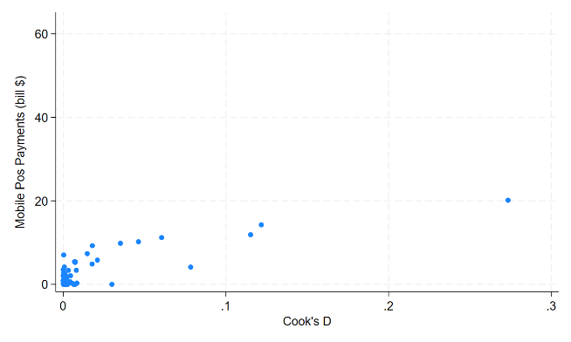

Figure 4
Scatter plot for 2nd outlier test for EU
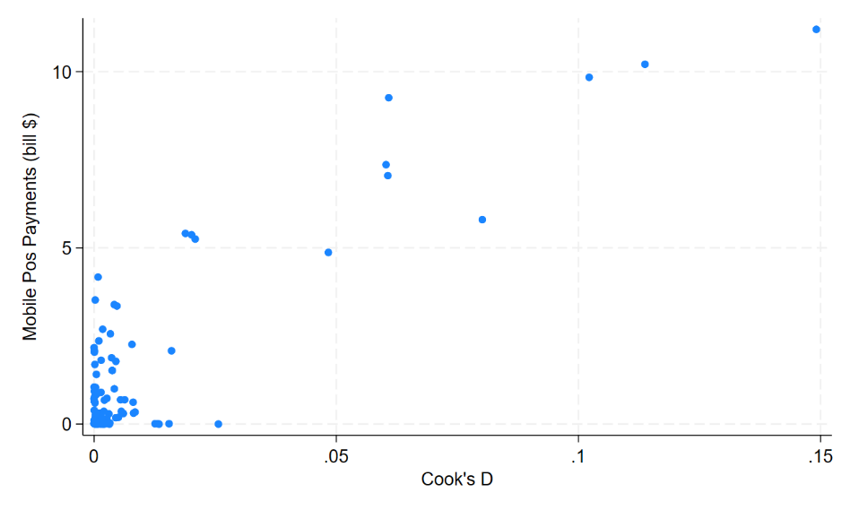

Figure 5
Scatter plot for 1st outlier test for SEA
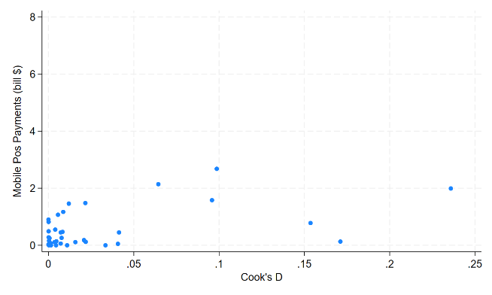
Figure 6
Scatter plot for 2nd outlier test for SEA
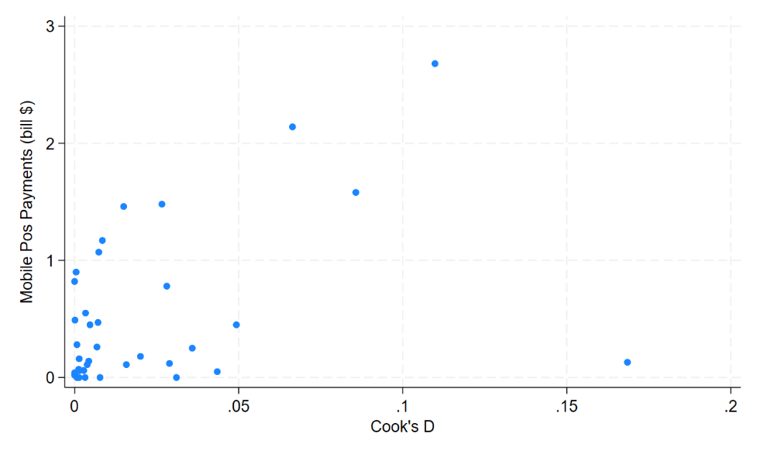
The multicollinearity test result is shown in Table 1. Low multicollinearity is shown by the Model A's VIF values, which vary from 1.18 to 1.86 with a mean of 1.41. Meanwhile, the VIF values in model B have a mean of 3.30 and a range of 2.15 to 6.45. The Fixed Broadband Subscriptions (FIX) variable is getting closer to a greater worry level but is still below the critical threshold of 10, therefore even if Southeast Asia's VIF values are higher than the EU's, they are still within an acceptable range. These findings show that multicollinearity is not a serious problem in any model, allowing us to move forward with more analyses without worrying about exaggerated variances across the predictors. Given the issues of heteroskedasticity and serial correlation, cluster regression will be employed to address these concerns and ensure the robustness of the regression models.
Table 1
VIF result
 | VIF Model A | VIF Model B
ACC | 1.25 | 2.16
SEC | 1.49 | 3.15
IND | 1.86 | 3.83
MOB | 1.19 | 2.15
FIX | 1.42 | 6.45
ATM | 1.18 | 2.55
AFF | 1.46 | 2.80
Mean VIF | 1.41 | 3.30

Stepwise Multiple Regression Test
Model A demonstrate robustness, as indicated by the r-squared values of 43.1% in the full model and 37.7% in the final model. This represents the variables that significantly explains the variance in the data. The notable increase in F-Value from the full model to final model suggests the model efficiency through the reduction of predictors. Conversely, Model B shows a notable decrease in r-squared from 49.8% in full model to 39.4% in the final model. This is likely due to removal of statistically insignificant variables in the stepwise regression process. Despite the reduction of explanatory variables, the final regression model of both Model A and Model B remain statistically significant with value of 0.000.
In terms of access to electricity, only Model A show a significant negative effect towards mPayment in EU-27 countries. This might indicate that the use of ePayment is saturated in terms of electricity access, or it might suggest that other macroeconomic dynamics where electricity access is no longer a primary driver for mPayment adoption. Next, secure internet servers show a positive and significant relationship with mPayment in both Model A and Model B. This suggest that higher number of secure servers, which is with enhance cybersecurity will influences mPayment volumes in EU-27 and SEA. This emphasis on digital security in boosting consumer confidence within a well-regulated regions market. Moreover, the number of individuals using the internet have a strong impact towards mPayment, highlighting that higher internet penetration correlate with higher mPayment transaction in Model B.
However, both mobile cellular subscription and fixed broadband subscriptions do not remain in the final regression model in Model A and Model B event though they are both show a positive coefficient in the full regression models. This implying that both variables is not a significant predictor of mPayment in the context of EU-27 and SEA. This result might reflect a market where mobile cellular subscription and fixed broadband subscriptions are widespread but other factors like consumer preferences play more significant roles.
In contrast, ATMs shows a negative significant relationship with mPayment in the EU-27 countries. Based on a report by Meyer and Teppa (2024), as digital payment preferences increase and ATM usage declines, banks may decide to intentionally close some of their locations in order to save money on maintenance. This is a financial adjustment made in response to shifting customer demands and the banking industry's overall digital revolution. As more consumers choose digital payment methods over traditional cash transactions, the demand for ATMs decreases which explained the finding.
Table 2
Regression Result for Model A and Model B
 | Model A |  | Model B
 | Full Model | Final Model | Full Model | Final Model
ACC | -1.278  (2.15)** | -0.467  (3.26)*** | -0.036  (0.49)
SEC | 0.035  (3.30)*** | 0.040  (3.14)*** | 0.007  (1.17) | 0.009  (4.85)***
IND | 0.066  (0.78) |  | 0.031  (1.31) | 0.046  (2.29)**
MOB | 0.012  (0.21) |  | -0.001  (0.22)
FIX | 0.211  (1.21) |  | 0.161  (1.30)
ATM | -0.115  (2.20)** | -0.124  (2.06)** | 0.015  (0.27)
AFF | -0.051  (0.69) |  | 0.024  (0.68)
Cons | 123.56 | 56.36 | -0.113 | -2.366
R-Squared | 0.4308 | 0.3772 | 0.4977 | 0.3939
F-Value | 16.93 | 46.09 | 7.19 | 67.30
Sig. Value | 0.000 | 0.000 | 0.0043 | 0.000
Sample Size | 103 | 103 | 37 | 37
Note: ***p-value is significant at 1% level, **p-value is significant at 5% level, *p-value is significant at 10% level

5. Conclusion and Recommendation
In conclusion, the study finds that the number of people utilising the internet and safe internet servers are important indicators of mPayment acceptance in the EU-27 and SEA areas. The findings suggest that in order to increase mPayment volumes, policymakers and businesses have to prioritise improving digital security and internet penetration. Nevertheless, mPayment usage was not strongly predicted by characteristics like fixed broadband subscriptions or mobile cellular subscriptions, suggesting that these technologies may have achieved saturation in the areas under study.
While the study provides valuable insights, it also has limitations. Two examples of these are the imbalanced panel dataset it uses and the exclusion of other potentially relevant factors. Future research could explore these areas further and consider more comprehensive datasets.

Acknowledgement
This paper was prepared with the support of the ODDEA Horizon Europe-MSCA-SE project.
Project No. 10108638. This support is gratefully acknowledged.

References
Adeleye, B. N., Adedoyin, F., & Nathaniel, S. (2021). The criticality of ICT-trade nexus on economic and inclusive growth. Information Technology for Development, 27(2), pp. 293-313. https://doi.org/10.1080/02681102.2020.1840323
Allen, J., Carbo-Valverde, S., Chakravorti, S., Rodriguez-Fernandez, F., & Ardic, O. (2022). Assessing incentives to increase digital payment acceptance and usage: A machine learning approach. PLOS ONE, 17(11), e0276203. https://doi.org/10.1371/journal.pone.0276203
Alotaibi, R., & Alghamdi, A. (2022). Investigating the security threats on using m-payment applications in Saudi Arabia: Exploratory study. International Journal on Advanced Science, Engineering and Information Technology, 12(5), pp. 1950-1955. https://doi.org/10.18517/ijaseit.12.5.16242
Alshubiri, F., Jamil, S. A., & Elheddad, M. (2019). The impact of ICT on financial development: Empirical evidence from the Gulf Cooperation Council countries. International Journal of engineering business management, 11(2), pp. 1-14. http://dx.doi.org/10.1177/1847979019870670
Apostu, S., Vasile, V., Marin, E., & Bunduchi, E. (2022). Factors influencing physicians migration—a case study from romania. Mathematics, 10(3), pp. 505. https://doi.org/10.3390/math10030505
Asian Development Bank. (2021). Asia’s Journey to Prosperity: Policy, Market, and Technology over 50 Years. https://dx.doi.org/10.22617/TCS190290
ASEAN. (2021). ASEAN Digital Integration Framework Action Plan. https://asean.org/wp-content/uploads/2020/12/Adopted-ASEAN-Digital-Integration-Framework.pdf
Bayar, Y., Gavriletea, M., & Păun, D. (2021). Impact of mobile phones and internet use on financial inclusion: Empirical evidence from the EU post-communist countries. Technological and Economic Development of Economy, 27(3), pp. 722-741. https://doi.org/10.3846/tede.2021.14508
Benami, E., & Carter, M. (2021). Can digital technologies reshape rural microfinance? Implications for savings, credit, & insurance. Applied Economic Perspectives and Policy, 43(4), pp. 1196-1220. https://doi.org/10.1002/aepp.13151
Bulkhairova, Z., Doszhan, R., Kuanova, L., & Beisembayev, G. (2023). Impact of COVID-19 on fintech industry of Kazakhstan: New challenges. Eurasian Journal of Economic and Business Studies, 1(67), pp. 70-81. https://doi.org/10.47703/ejebs.v1i67.258
Breusch, T. S., & Pagan, A. R. (1980). The Lagrange Multiplier test and its applications to model specification in econometrics. The Review of Economic Studies, 47(1), pp. 239-253.
Cao, T. (2021). The study of factors on the small and medium enterprises' adoption of mobile payment: Implications for the COVID-19 era. Frontiers in Public Health, 9. https://doi.org/10.3389/fpubh.2021.646592
Capegemini. (2020, April 29). COVID-19 and the Financial Services Consumer, Capgemini Worldwide. Retrieved March 7, 2022, from https://www.capgemini.com/research/covid-19-and-the-financial-services-consumer/
Chow, G. C. (1960). Tests of equality between sets of coefficients in two linear regressions. Econometrica, 28(3), pp. 591-605. http://www.stat.ucla.edu/~nchristo/statistics100C/testing_equations_paper.pdf
Cojoianu, T., Clark, G., Hoepner, A., Pažitka, V., & Wójcik, D. (2020). Fin vs. tech: Are trust and knowledge creation key ingredients in fintech start-up emergence and financing? Small Business Economics, 57(4), 1715-1731. https://doi.org/10.1007/s11187-020-00367-3
Cook, R. D. (1977). Detection of influential observation in linear regression. Technometrics, 19(1), 15-18. http://www.stat.ucla.edu/~nchristo/statistics100C/1268249.pdf
Delaporte, A., Bahia, K., Carboni, I., Cruz, G., Jeffrie, N., Sibthorpe, C., Suardi, S., & Groenestege, M. T. (2021). Mobile Internet Connectivity 2021: Southeast Asia. GSMA. https://www.gsma.com/r/wp-content/uploads/2021/09/The-State-of-Mobile-Internet-Connectivity-Report-2021.pdf
Djayapranata, G., & Setyawan, A. (2021). Trust or usefulness? QR code payment among millennials in a disrupted market. Proceedings of the 1st International Conference on Business & Social Sciences (ICOBUSS 2020). https://doi.org/10.2991/aebmr.k.210628.032
Ekong, U., & Ekong, C. (2022). Digital currency and financial inclusion in Nigeria: Lessons for development. Journal of Internet and Digital Economics, 2(1), pp. 46-67. https://doi.org/10.1108/jide-11-2021-0018
Esselink, H., & Hernández, L. (2017). The use of cash by households in the euro area. European Central Bank Occasional Paper Series No 201. https://doi.org/10.2866/377081
European Commission. (2020). Digital Economy and Society Index (DESI) 2020. https://digital-strategy.ec.europa.eu/en/library/digital-economy-and-society-index-desi-2020
GSMA. (2019). The impact of mobile money on monetary and financial stability in Sub-Saharan Africa. https://www.gsma.com/mobileeconomy/wp-content/uploads/2019/02/GSMA-Mobile-Economy-2019.pdf
Hanif, A., & Mohamad Shukri, N. H. (2024). Towards a cashless society - Examining the Impact of Digital Infrastructure on mPayment Transactions (A Cross-Region Analysis).xlsx [Data set]. Zenodo. https://doi.org/10.5281/zenodo.13830758
Hassan, A., Shukur, Z., & Hasan, M. (2020). An efficient secure electronic payment system for e-commerce. Computers, 9(3), 66. https://doi.org/10.3390/computers9030066
Hausman, J. A. (1978). Specification tests in econometrics. Econometrica, 46(6), pp. 1251-1271. http://www.econ.uiuc.edu/~econ536/Papers/hausman78.pdf
Hee, O., Ying, K., Kowang, T., & Ping, L. (2020). What influences urbanites’ mobile payment adoption? The moderating roles of demographic divides. Pertanika Journal of Social Sciences and Humanities, 28(4). https://doi.org/10.47836/pjssh.28.4.42
IEA. (2020). World Energy Outlook 2020. IEA, Paris. https://www.iea.org/reports/world-energy-outlook-2020
Jesuthasan, S., & Umakanth, N. (2021). Impact of behavioural intention on e-wallet usage during COVID-19 period: A study from Sri Lanka. Sri Lanka Journal of Marketing, 7(2), pp. 24-48. https://doi.org/10.4038/sljmuok.v7i2.63
Khikmah, K., Indahwati, I., Fitrianto, A., Erfiani, E., & Amelia, R. (2022). Backwards stepwise binary logistic regression for determination population growth rate factor in Java Island. Jambura Journal of Mathematics, 4(2), pp. 177-187. https://doi.org/10.34312/jjom.v4i2.13529
Kim, J. (2019). Multicollinearity and misleading statistical results. Korean Journal of Anesthesiology, 72(6), pp. 558-569. https://doi.org/10.4097/kja.19087
Kouladoum, J. C. (2023). Digital infrastructural development and inclusive growth in Sub-Saharan Africa. Journal of Social and Economic Development, 25(2), pp. 403-427. https://doi.org/10.1007/s40847-023-00240-5
Ligon, V., Shaikh, A., & Williams, T. (2019). Barriers to digital payment technology adoption among small-scale merchants. International Journal of Digital Commerce, 17(2), pp. 112-130. https://doi.org/10.1080/10580530.2019.1562506
Liu, Y., Luo, J., & Zhang, L. (2020). The effects of mobile payment on consumer behavior. Journal of Consumer Behaviour, 20(3), pp. 512-520. https://doi.org/10.1002/cb.1880
Meyer, J., & Teppa, F. (2024). Consumers' payment preferences and banking digitalisation in the euro area. European Central Bank Working Paper No 2915. https://doi.org/10.2866/4294
Mlambo, C., & Msosa, S. K. (2020). The effect of financial technology on money demand: Evidence from selected African states. International Journal of Economics and Business Administration, 8(1), pp. 366-373. https://doi.org/10.35808/ijeba/430
Montgomery, D. C., Peck, E. A., & Vining, G. G. (2012). Introduction to linear regression analysis (5th ed.). John Wiley & Sons. https://ocd.lcwu.edu.pk/cfiles/Statistics/Stat-503/IntroductiontoLinearRegressionAnalysisbyDouglasC.MontgomeryElizabethA.PeckG.GeoffreyViningz-lib.org.pdf
Najaf, K., Schınckus, C., & Liew, C. (2020). VAR and market value of fintech companies: An analysis and evidence from global data. Managerial Finance, 47(7), pp. 915-936. https://doi.org/10.1108/mf-04-2020-0169
Najib, M., Ermawati, W., Fahma, F., Endri, E., & Suhartanto, D. (2021). Fintech in the small food business and its relation with open innovation. Journal of Open Innovation Technology Market and Complexity, 7(1), pp. 88. https://doi.org/10.3390/joitmc7010088
Narayan, S., & Sahminan, S. (2018). Has fintech influenced Indonesia’s exchange rate and inflation? Buletin Ekonomi Moneter Dan Perbankan, 21(2), pp. 189-202. https://doi.org/10.21098/bemp.v21i2.966
Ng, A., & Kwok, B. (2017). Emergence of fintech and cybersecurity in a global financial centre. Journal of Financial Regulation and Compliance, 25(4), 422-434. https://doi.org/10.1108/jfrc-01-2017-0013
Ngo, H., & Nguyen, L. (2022). Consumer adoption intention toward fintech services in a bank-based financial system in Vietnam. Journal of Financial Regulation and Compliance, 32(2), pp. 153-167. https://doi.org/10.1108/jfrc-08-2021-0061
Nguyen, T. (2022). Does financial knowledge matter in using fintech services? Evidence from an emerging economy. Sustainability, 14(9), pp. 5083. https://doi.org/10.3390/su14095083
Nnaomah, U. (2024). Digital banking and financial inclusion: A review of practices in the USA and Nigeria. Finance & Accounting Research Journal, 6(3), pp. 463-490. https://doi.org/10.51594/farj.v6i3.971
Ong, H., & Chong, L. (2022). The effect of cashless payments on the internet and mobile banking. Journal of Financial Services Marketing, 28(1), pp. 178-188. https://doi.org/10.1057/s41264-022-00145-0
Owusu-Agyei, S., Okafor, G., Chijoke-Mgbame, A. M., Ohalehi,P., & Hasan, H. (2020). Internet adoption and financial development in sub-Saharan Africa. Technological Forecasting and Social Change 161 (2020): 120293. https://doi.org/10.1016/j.techfore.2020.120293
Putrevu, J., & Mertzanis, C. (2023). The adoption of digital payments in emerging economies: challenges and policy responses. Digital Policy, Regulation and Governance, Vol. ahead-of-print No. ahead-of-print. https://doi.org/10.1108/DPRG-06-2023-0077
Rahman, M., Ismail, I., Bahri, S., & Rahman, M. (2022). An empirical analysis of cashless payment systems for business transactions. Journal of Open Innovation Technology Market and Complexity, 8(4), pp. 213. https://doi.org/10.3390/joitmc8040213
Rajagukguk, W., Purba, J. T., & Budiono, S. (2021). Economic Development and Mobile Cellular Subscription. In: Proceedings of the International Conference on Industrial Engineering and Operations Management. IEOM Society International, Rome, Italy. pp. 1179-1186. http://repository.uki.ac.id/id/eprint/8854
Sahi, A. M., Khalid, H., Abbas, A. F., & Khatib, S. F. A. (n.d.). The evolving research of customer adoption of digital payment: Learning from content and statistical analysis of the literature. Journal of Open Innovation Technology Market and Complexity, 7(4), pp. 230. https://doi.org/10.3390/joitmc7040230
Sanga, B., & Aziakpono, M. (2022). The impact of technological innovations on financial deepening: Implications for SME financing in Africa. African Development Review, 34(4), pp. 429-442. https://doi.org/10.1111/1467-8268.12668
Shamim, F. (2007). The ICT environment, financial sector and economic growth: A cross‐country analysis. Journal of Economic Studies, 34(4), pp. 352-370. https://doi.org/10.1108/01443580710817452
Shrestha, N. (2020). Detecting multicollinearity in regression analysis. American Journal of Applied Mathematics and Statistics, 8(2), pp. 39-42. https://doi.org/10.12691/ajams-8-2-1
Singh, N., Srivastava, S., & Sinha, N. (2017). Consumer preference and satisfaction of M-wallets: A study on North Indian consumers. International Journal of Bank Marketing, 35(6), pp. 944–965. https://doi.org/10.1108/IJBM-06-2016-0086
Singh, N., Srivastava, S., & Sinha, N. (2020). Determining factors in the adoption and recommendation of mobile wallet services in India: Analysis of the effect of innovativeness, stress to use and social influence. International Journal of Information Management, 50, pp. 191–205. https://doi.org/10.1016/j.ijinfomgt.2019.05.022
Song, S., Tian, Y., & Zhou, D. (2021). Reverse logistics network design and simulation for automatic teller machines based on carbon emission and economic benefits: A study of the Anhui province ATMs industry. Sustainability, 13(20), pp. 11373. https://doi.org/10.3390/su132011373
Stryjak, J. (2020). The Mobile Economy 2020. GSMA. https://www.gsma.com/solutions-and-impact/connectivity-for-good/mobile-economy/wp-content/uploads/2020/03/GSMA_MobileEconomy2020_Global.pdf
Turangan, J. (2023). Factors influencing the intention of behavior in using GoPay mobile payment. International Journal of Applied Economics and Business, 1(4), pp. 2569-2576. https://doi.org/10.24912/ijaeb.v1i4.2569-2576
Varalakshmi, D. (2024). Cyber security in digital payments: An empirical study. Asian Journal of Management and Commerce, 5(1), pp. 305-310. https://doi.org/10.22271/27084515.2024.v5.i1d.274
World Bank. (2021). Digital Financial Inclusion: Emerging Policy Approaches. https://documents.worldbank.org/en/publication/documents-reports/documentdetail/718111587147227244/digital-financial-inclusion-emerging-policy-approaches
Xiao, Y., & Chorzempa, M. (2020). How Digital Payments Can Help Countries Cope with Pandemics, World Economic Forum. Retrieved March 7, 2022, from https://www.weforum.org/agenda/2020/05/digital-payments-cash-and-covid-19-pandemics/
Xie, J. (2023). Influencing factors on the adoption of online payment systems among the elderly and middle aged people. Highlights in Science Engineering and Technology, 49, pp. 256-260. https://doi.org/10.54097/hset.v49i.8515
Zhu, H., & Zhou, Z. (2016). Analysis and outlook of applications of blockchain technology to equity crowdfunding in China. Financial Innovation, 2(1). https://doi.org/10.1186/s40854-016-0044-7

