**Dissemination report**

**Date:** 14 May 2025

**Venue:** Arshad Ayub Graduate Business School, Universiti Teknologi MARA (UiTM)

**Organizing institution:** Universiti Teknologi MARA (UiTM), Malaysia and University of Economics in Bratislava, Slovakia

**Description:**

**Title: Assistant Professor Dr. Andrej** **Přívara Completes Research Secondment at Arshad Ayub Graduate Business School, UiTM**

Arshad Ayub Graduate Business School (AAGBS), Universiti Teknologi MARA (UiTM), Malaysia, was honored to host Assistant Professor Dr. Andrej Přívara from the University of Economics in Bratislava, Slovakia, for a two-month research secondment from 10th March to 10th May 2025. His visit was conducted under the prestigious Horizon-MSCA Staff Exchange Program, co-funded by the European Union, as part of the collaborative research initiative titled "Overcoming Digital Divide in Europe and Southeast Asia (ODDEA)."

During his secondment, Dr. Přívara contributed to Work Package 4 of the ODDEA project, which focuses on a granular examination of the digital divide in individual partner countries. His research centered on utilizing disaggregated data to explore digitalization dynamics within and across regions, with a particular emphasis on Malaysia and European Union member states.

Supervised by Professor Dr. Tan Peck Leong, Professor of Economics at UiTM, Dr. Přívara actively engaged in scholarly exchanges and collaborative discussions. He held regular research meetings with Prof. Dr. Tan and other members of the UiTM ODDEA research team, including Associate Professor Dr. Azlina Hanif, Associate Professor Dr. Arlinah Abd Rashid, and Associate Professor Dr. Nor Irvoni Mohd Ishar. These interactions provided a valuable platform for interdisciplinary insights and comparative policy analysis relevant to the digital transformation agendas of both regions.

A highlight of Dr. Přívara’s stay was his knowledge-sharing session on 9th May 2025, titled “Digitalization Dynamics and Challenges: Lessons from Europe and Southeast Asia.” The session, attended by UiTM faculty, postgraduate students, and project collaborators, was held in a hybrid format (on-site and online), further strengthening ODDEA’s commitment to inclusive academic dissemination.

In his presentation, Dr. Přívara shared comparative findings on digital infrastructure, digital literacy, and policy frameworks between selected EU countries and Malaysia. The session also featured insights from a survey conducted among UiTM undergraduate students, aimed at capturing students’ perceptions and engagement with digital technologies. This data not only enriched his study but also contributed directly to ODDEA's objectives under Work Package 4, particularly in assessing digital readiness in Southeast Asia.

Dr. Přívara described his secondment experience as both productive and intellectually stimulating, noting the warm hospitality and vibrant academic environment at UiTM. His visit reflects the significance of international collaboration in addressing shared global challenges, such as bridging the digital divide and promoting equitable digital access.

UiTM looks forward to future engagements with Dr. Přívara and the University of Economics in Bratislava, further strengthening research ties between Europe and Southeast Asia under the ODDEA project framework.

**Photos:**

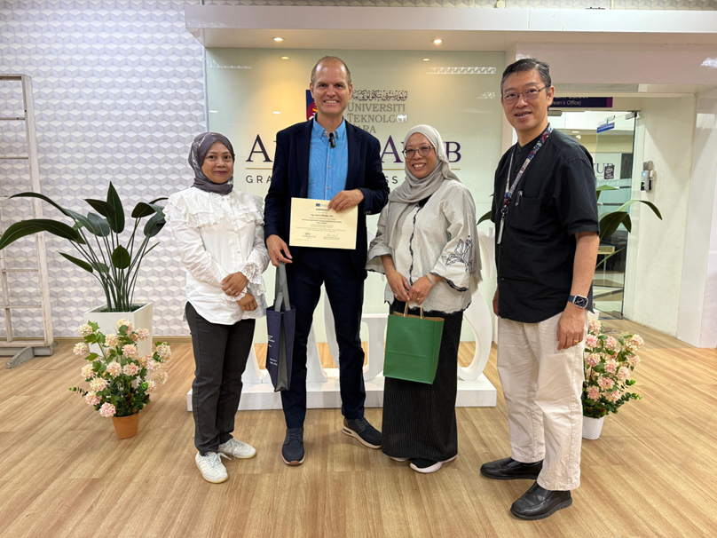

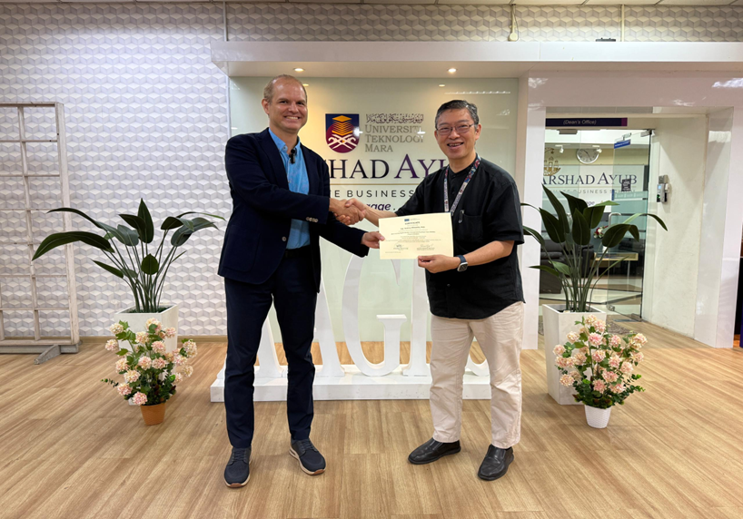

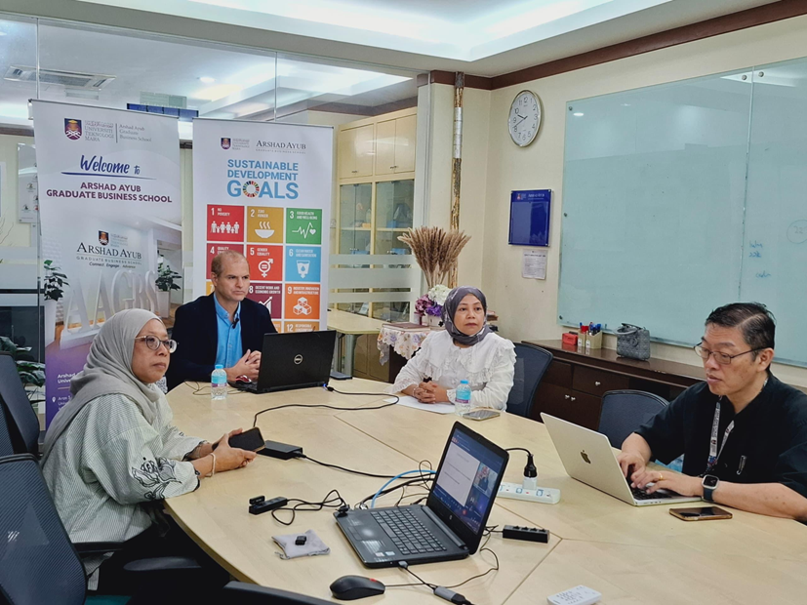

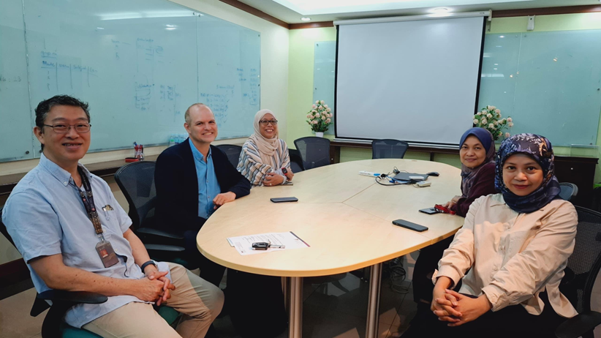

**Report prepared by:** Associate Prof. Dr Azlina Hanif, UiTM