Dissemination report

Date: 23 April 2026
Venue: Arshad Ayub Graduate Business School, UiTM
Organizing institution: UiTM
Description:
Focus Group Session for ODDEA Work Package 4 Data Collection at UiTM
A focus group session was successfully conducted on 23 April 2026 at the Arshad Ayub Graduate Business School (AAGBS), Universiti Teknologi MARA (UiTM), as part of the data collection process for Work Package 4 (WP4) under the Overcoming Digital Divide in Europe and Southeast Asia (ODDEA) project. This project is funded under the Horizon Europe Marie Skłodowska-Curie Actions (MSCA) Staff Exchange programme.
The session was organised by the ODDEA research team at UiTM, led by Assoc. Prof. Dr. Azlina Hanif, with team members Prof. Dr. Tan Peck Leong, Assoc. Prof. Dr. Arlinah Abd Rashid, and Assoc. Prof. Dr. Nor Irvoni Mohd Ishar. The discussion was moderated by Dr. Zoel-Fazle Omar, who guided participants through a series of structured questions aimed at eliciting insights on the current state of digitalisation, challenges, and opportunities within the Malaysian context.
The focus group brought together a diverse group of participants from industry and relevant organisations, including representatives from Progressture Solar, Malaysian Cryptology Technology and Management Centre, Malaysia Digital Economy Corporation (MDEC), Sime Motors, Mitsubishi, and the Association of Banks in Malaysia (ABM). The participants included Dr. Muhammad Haziq B. Mohammed, Mdm Hazlin Abd Rani, Mdm Jocelyn Chan, Dr. Muhammad Sufyan Basri, Mr. Loo Chuan Wei, Mr. Shah Redza Shahrin, Dr. Solahuddin Shamsuddin, and Ms. Sarah Mock.
The primary objective of the session was to gather qualitative insights to support the development of detailed, country-specific micro datasets, contributing to a deeper understanding of the digital gap at the national level. The discussion provided valuable perspectives on digital adoption, institutional factors, and sectoral differences, which will inform WP4’s analysis and contribute to evidence-based policy recommendations.
The session concluded with strong engagement from participants, reflecting the relevance of the research and the importance of multi-stakeholder collaboration in addressing the digital divide.
Photos:

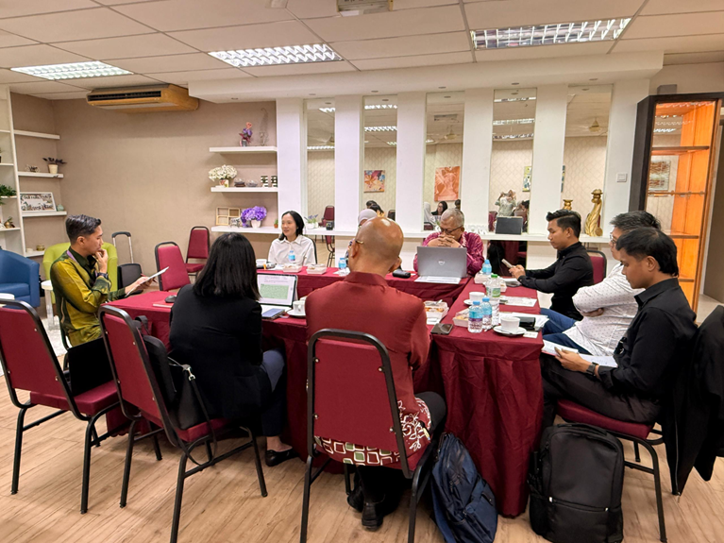

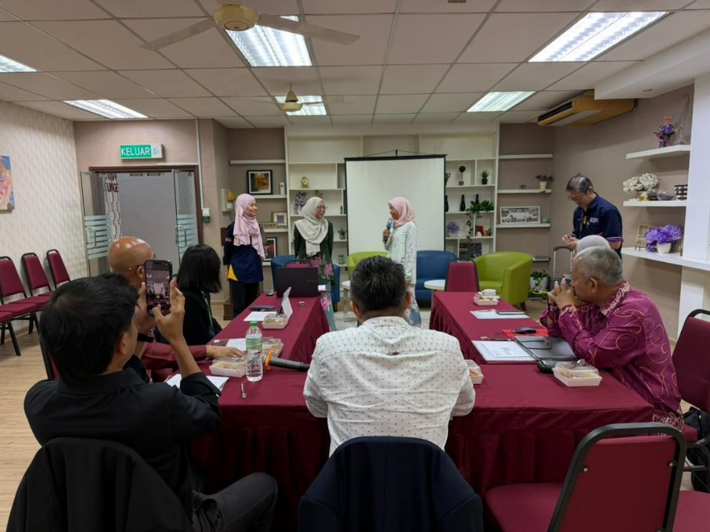

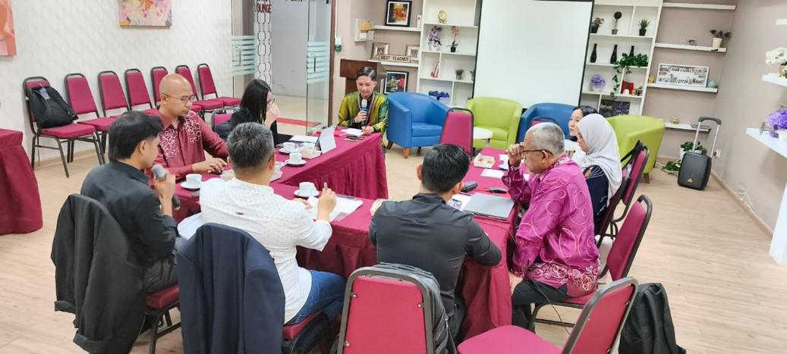

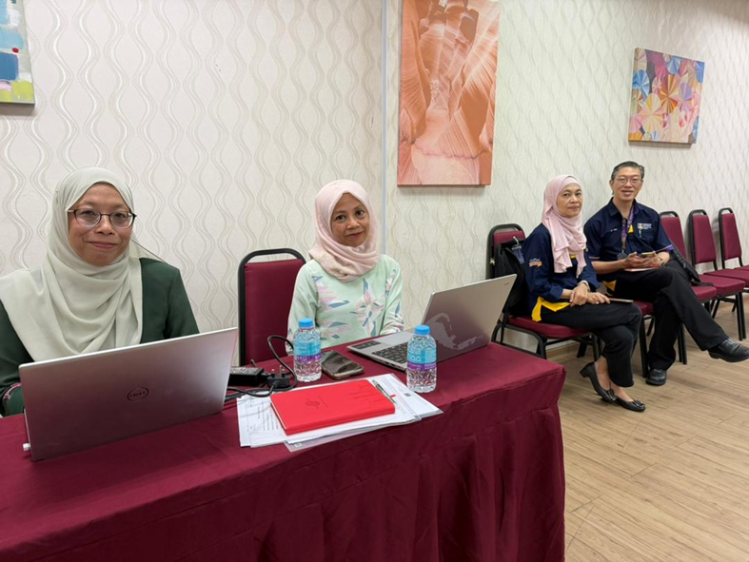

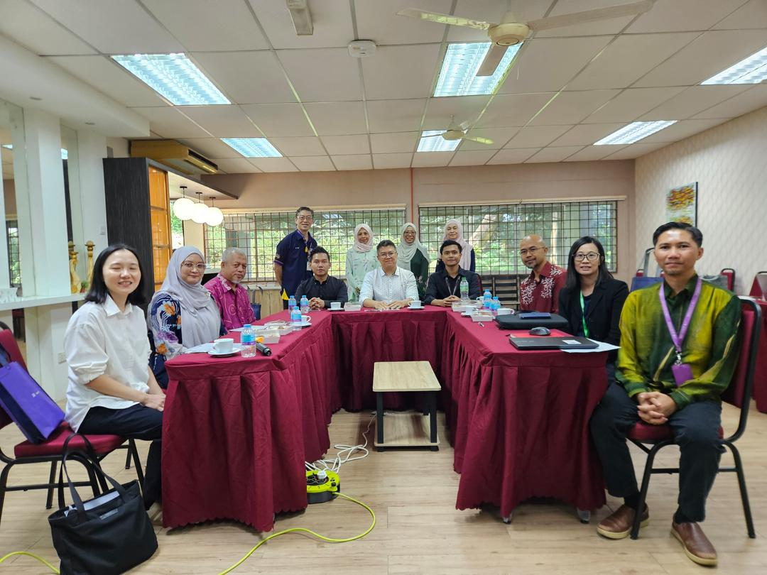

Report prepared by: Associate Prof Dr Azlina Hanif, UiTM

