Dissemination report

Date: 4 May 2026
Venue: Arshad Ayub Graduate Business School (AAGBS), UiTM
Organizing institution: UiTM
Description:
Arshad Ayub Graduate Business School (AAGBS), Universiti Teknologi MARA (UiTM), is pleased to host two doctoral researchers under the “Overcoming Digital Divide in Europe and Southeast Asia (ODDEA)” program, a collaborative initiative funded by the Horizon Europe Marie Skłodowska-Curie Actions.
Ms. Borbála Szedmák, a doctoral student from Széchenyi István University of Győr, undertook her two-month research secondment at AAGBS from April to May 2026. During her stay, she actively engaged with the academic community, participating in a networking session with faculty members including Prof. Dr. Syed Jamal, Assoc. Prof. Dr. Mior Harris Mior Harun, the Dean Prof. Dr. Norzanah Mat Nor, and Assoc. Prof. Dr. Siti Zaleha Sahak. The session provided a valuable platform for interdisciplinary exchange and the sharing of insights related to digitalisation, institutional frameworks, and regional development.
More recently, AAGBS welcomed Mr. Dominik Liszkai, also from Széchenyi István University of Győr, for his one-month research secondment in May 2026. Upon his arrival, Mr. Liszkai met with the ODDEA UiTM research team comprising Prof. Dr. Tan Peck Leong, Assoc. Prof. Dr. Azlina Hanif (project lead at UiTM), Assoc. Prof. Dr. Arlinah Abd Rashid, and Assoc. Prof. Dr. Nor Irvoni Mohd Ishar. The initial engagement focused on aligning research objectives, discussing work package 4, and identifying opportunities for collaborative outputs.
Both secondments form part of the broader ODDEA initiative aimed at advancing understanding of digitalisation and addressing digital capability gaps between Europe and Southeast Asia. At AAGBS, the visiting researchers are provided with a dynamic academic environment that supports knowledge exchange, joint research activities, seminars, and capacity-building efforts. Their presence further strengthens international collaboration, enhances research integration across partner institutions, and contributes to the project’s mission of inclusive and institutionally supported digital transformation across regions.
AAGBS remains committed to supporting the objectives of the ODDEA project by facilitating impactful research secondments, promoting cross-border academic collaboration, and contributing to high-quality research outputs with policy relevance.
Photos:

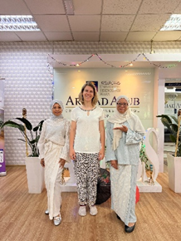
Ms. Borbála Szedmák with Assoc Prof Dr Azlina Hanif and Assoc Prof Dr Arlinah Abd Rashid

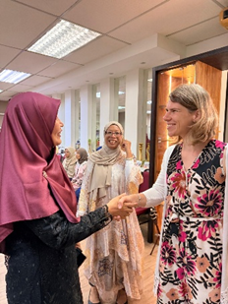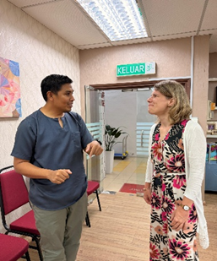
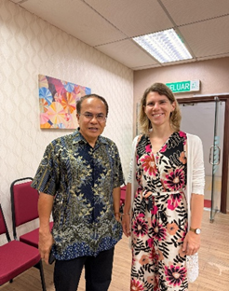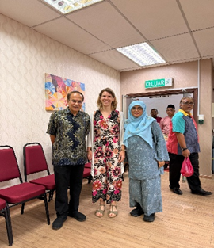

Ms. Borbála Szedmák at AAGBS Networking Session

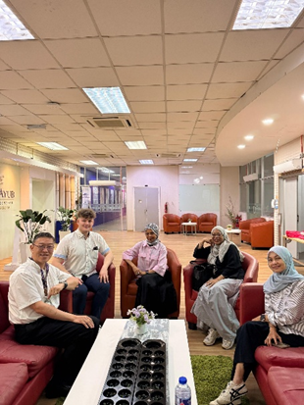

Mr. Dominik Liszkai with the ODDEA core researchers Prof Dr Tan Peck Leong, Assoc. Prof Dr Azlina Hanif, Assoc. Prof Dr Arlinah Abd Rashid and Assoc. Prof Dr Nor Irvoni Mohd Ishar

Report prepared by: Associate Prof Dr Azlina Hanif, UiTM

