Dissemination report

Date: 8 June 2026
Venue: UiTM
Organizing/Host institution: UiTM
Sending institution: AGH
Description:
UiTM Welcomes Ms. Agnieszka Choczyńska from AGH University of Krakow for ODDEA Research Secondment
Universiti Teknologi MARA (UiTM) is pleased to welcome Ms. Agnieszka Choczyńska from AGH University of Krakow, Poland, who is undertaking a two-month research secondment at UiTM from 1 June 2026 until 31 July 2026 under the Overcoming Digital Divide in Europe and Southeast Asia (ODDEA) project.
Upon her arrival at Arshad Ayub Graduate Business School (AAGBS), UiTM, Ms. Choczyńska was warmly welcomed by Professor Dr. Tan Peck Leong and Associate Professor Dr. Nor Irvoni Mohd Ishar at the AAGBS Meeting Room. The welcoming session provided an opportunity for discussions on the research agenda, expected outcomes, and collaborative activities that will be undertaken throughout her secondment, ensuring alignment with the objectives and deliverables of the ODDEA project.
This mobility continues the series of collaborative research exchanges undertaken by ODDEA researchers across partner institutions to achieve the deliverables of Work Package 3 (WP3): The Quantitative Analysis of Causes of Observed Digital Difference Among the EU Economies and Southeast Asian Economies. Building upon the work carried out during previous secondments, the current research activity further strengthens academic collaboration and contributes to the ongoing development of quantitative evidence on digital disparities and digital transformation across regions.
Supervised by Professor Dr. Tan Peck Leong, with the support of the UiTM ODDEA research team, Ms. Choczyńska's research during her stay at UiTM will focus on expanding the ASEAN Digital Integration Index to include additional countries and examining how digital development can mitigate the adverse effects of external shocks, such as global trade tensions and geopolitical conflicts, including the Middle East conflict. The study aims to generate empirical evidence on the role of digital integration in enhancing economic resilience and supporting sustainable development.
AAGBS and UiTM warmly welcome Ms. Agnieszka Choczyńska and wishes her a productive and successful research secondment. Her participation is expected to further strengthen the longstanding collaboration between UiTM and AGH University of Krakow while contributing meaningfully to the successful completion of the ODDEA Work Package 3 research agenda.

Photos:

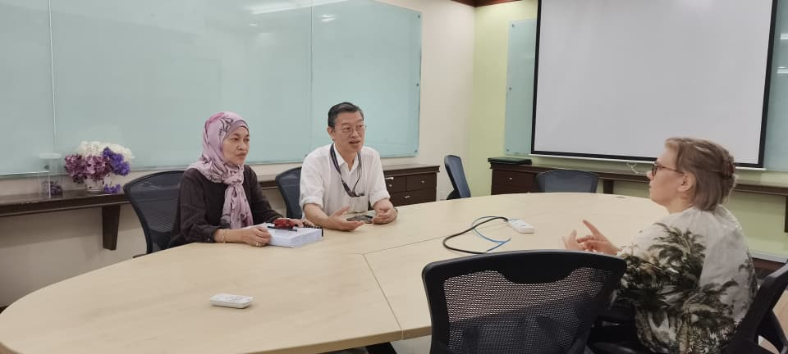

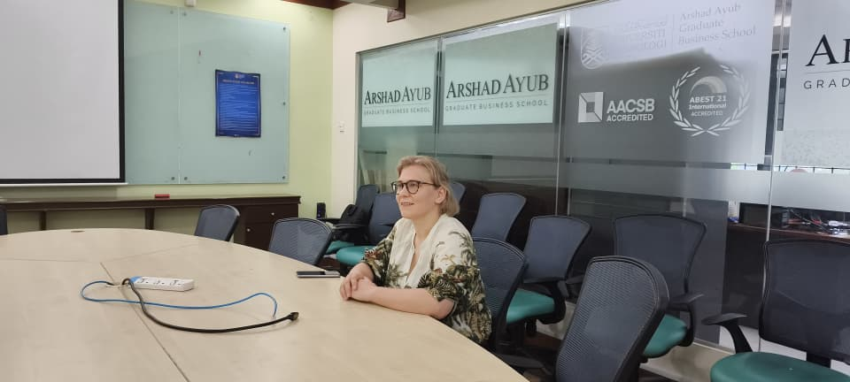

Report prepared by: Assoc. Prof. Dr Azlina Hanif, UiTM

