Dissemination report

Date: 30 May 2026
Venue: AGH Krakow, Poland
Organizing/Host institution: AGH
Sending institution: UiTM
Description:
We are pleased to announce that Dr. Nur Arfah Mustapha and Dr. Zoel-Fazlee, UiTM researchers have officially commenced their research secondment at the AGH University of Krakow in Poland. This academic exchange is being undertaken as part of the ODDEA project. Since their arrival, both researchers have actively integrated into the university's academic community, participating in a variety of institutional programs, including the recent student research conference.
Over the course of this one-month secondment, Dr. Nur Arfah and Dr. Zoel-Fazlee are directly contributing to the project’s Work Package 4. Their research focuses on a comprehensive qualitative analysis carried out among various firms, industrial clusters, and individuals. By assessing these distinct levels, the study aims to identify the specific socio-economic and structural barriers that contribute to regional digital disparities.
This initiative highlights a significant collaboration with the host research team at AGH University. The joint efforts are being coordinated by Dr. Joanna Duda and Dr. Rafal Kusa, whose expertise ensures a streamlined alignment of research methodologies between the participating European and Southeast Asian institutions.
Ultimately, the findings generated from this collaborative research will yield critical insights into regional digitalization. The final data will enable the research group to formulate comprehensive policy recommendations designed to stimulate a more dynamic, equitable, and targeted digital progression within individual partner countries, as well as across the broader Southeast Asian and European regions.
Photos:

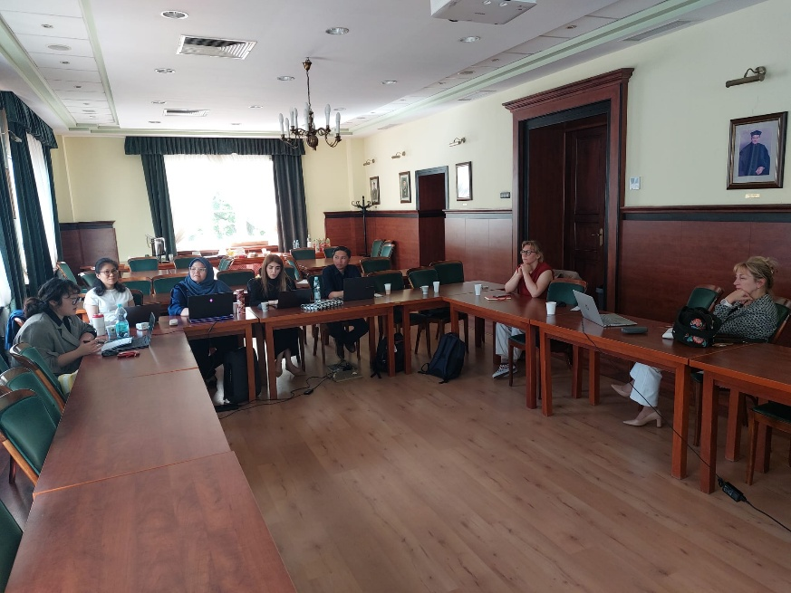

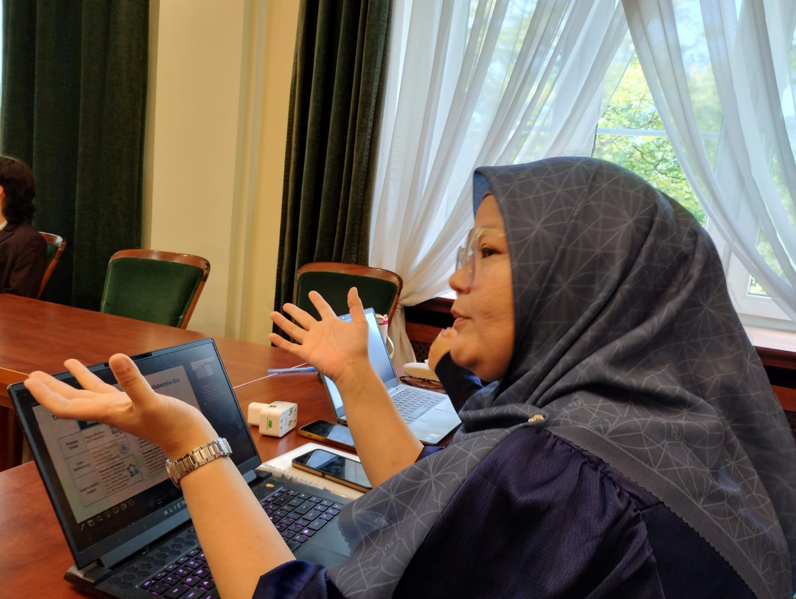

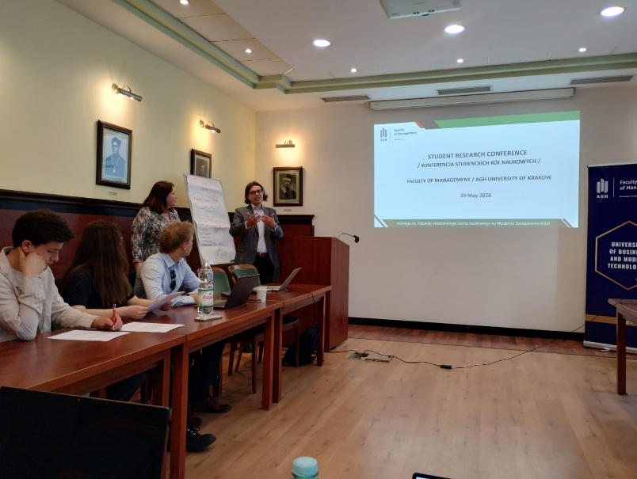

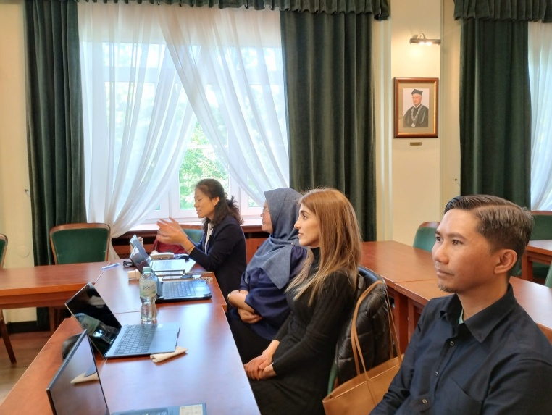

Report prepared by: Dr Zoel-Fazlee Omar, UiTM

