Dissemination report

Date: 25 May 2026
Venue: EUBA
Organizing/Host institution: EUBA
Sending institution: UiTM
Description:
As part of the ongoing collaboration under the Horizon Europe MSCA Staff Exchanges project Overcoming Digital Divide in Europe and Southeast Asia (ODDEA), Associate Professor Dr. Azlina Hanif and Associate Professor Dr. Arlinah Abd Rashid from Universiti Teknologi MARA (UiTM), Malaysia, are currently undertaking a research secondment at the University of Economics in Bratislava (EUBA), Slovakia.
This marks the second research mobility for both researchers to EUBA under Work Package 3 (WP3), which focuses on the quantitative analysis of the role of institutions and market structures in shaping the impact of digitalisation. The current secondment builds upon previous collaborative work and further strengthens the research partnership between UiTM and EUBA.
Working closely with Professor Dr. Anetta Caplánová from the Faculty of Economics and Finance, EUBA, the researchers are investigating how institutional quality and market conditions influence digital development outcomes across ASEAN economies.
Dr. Azlina Hanif's research focuses on identifying the institutional quality threshold at which digitalisation begins to effectively reduce the digital gap among ASEAN member states. By employing advanced threshold regression techniques, the study seeks to determine the level of institutional development required for digital investments and technologies to translate into meaningful reductions in digital disparities across the region. The findings are expected to provide important policy insights for ASEAN countries seeking to achieve more inclusive digital transformation.
Meanwhile, Dr. Arlinah Abd Rashid is examining the role of institutional quality and market structures in supporting the digitalisation development of micro, small and medium-sized enterprises (MSMEs) in ASEAN. Her research explores how governance quality, regulatory frameworks and market environments can facilitate the adoption and effective utilisation of digital technologies among MSMEs, which remain a critical driver of economic growth and employment throughout the region.
The secondment provides an opportunity for intensive research collaboration, methodological discussions, data analysis, and joint publication activities. It also contributes directly to the objectives of ODDEA by generating evidence-based insights on the factors that enable countries and businesses to harness the benefits of digitalisation while reducing digital divides.
The collaboration between UiTM and EUBA continues to demonstrate the value of international research partnerships in addressing contemporary challenges related to digital transformation, institutional development, and inclusive economic growth across Europe and Southeast Asia.
Photos:

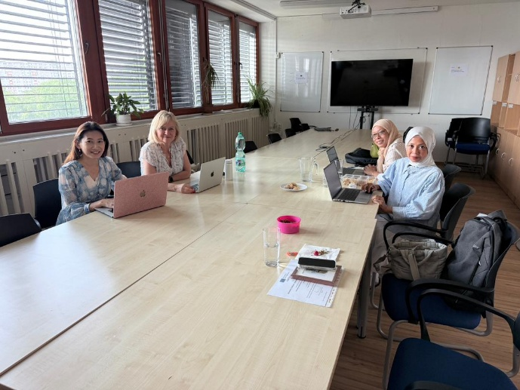

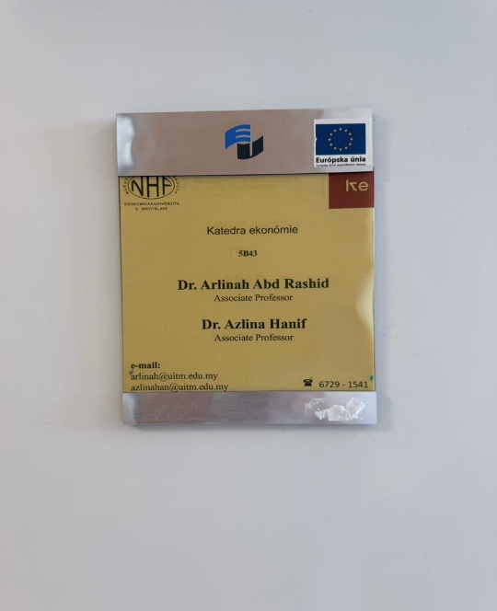

Report prepared by: Assoc. Prof. Dr Azlina Hanif, UiTM

