Jan 9, 2026
ODDEA project SIU at ICO NIDA (Already posted on ODDEA fb)
https://www.facebook.com/share/p/1CLjCNnPUE/

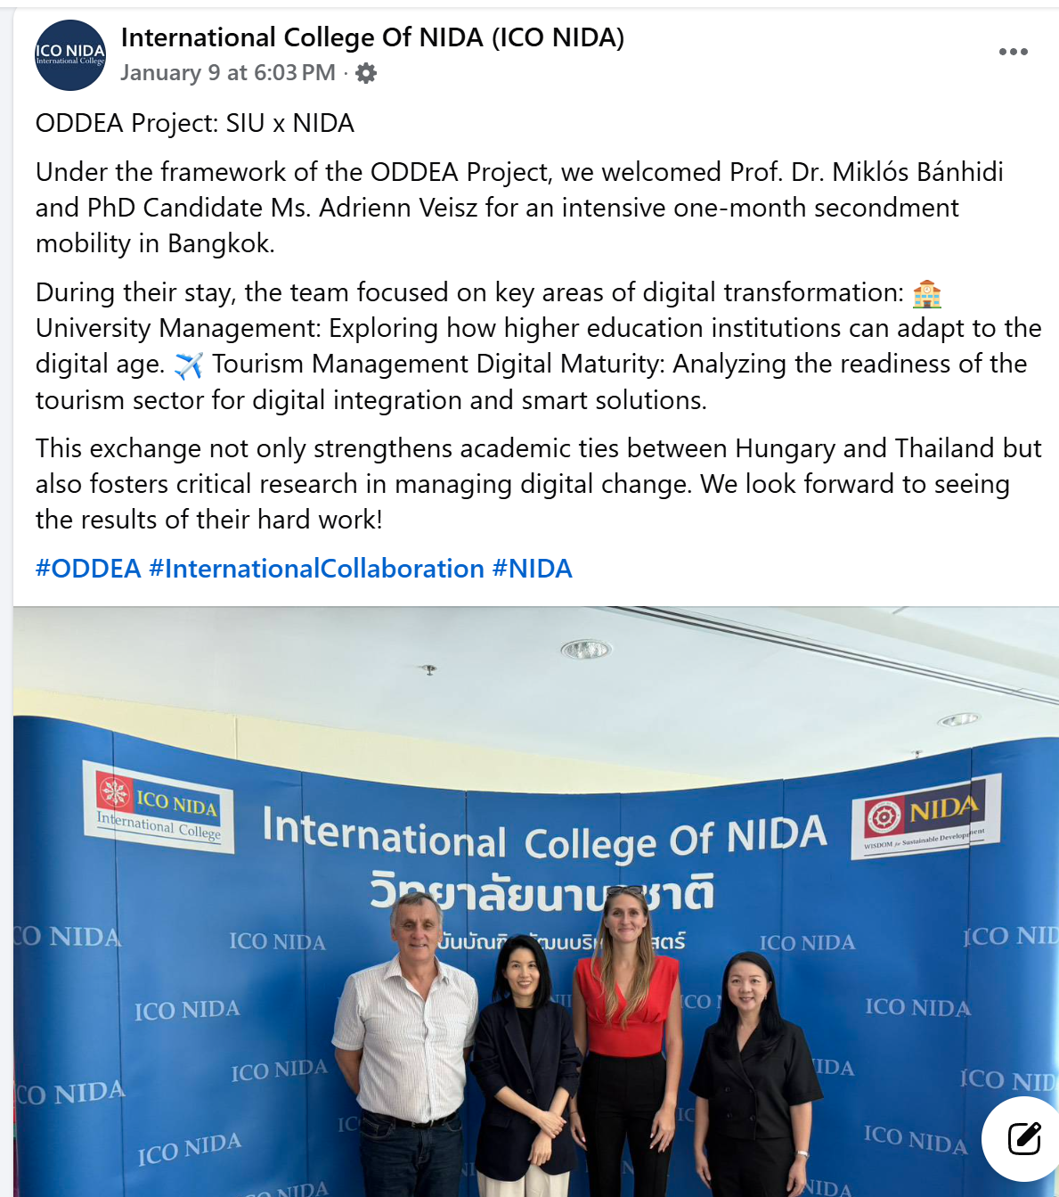

June 23, 2026
Dr Yuanfeng Cai visited UEK (Already posted on ODDEA fb)
https://www.facebook.com/share/p/1AdvANKkka/

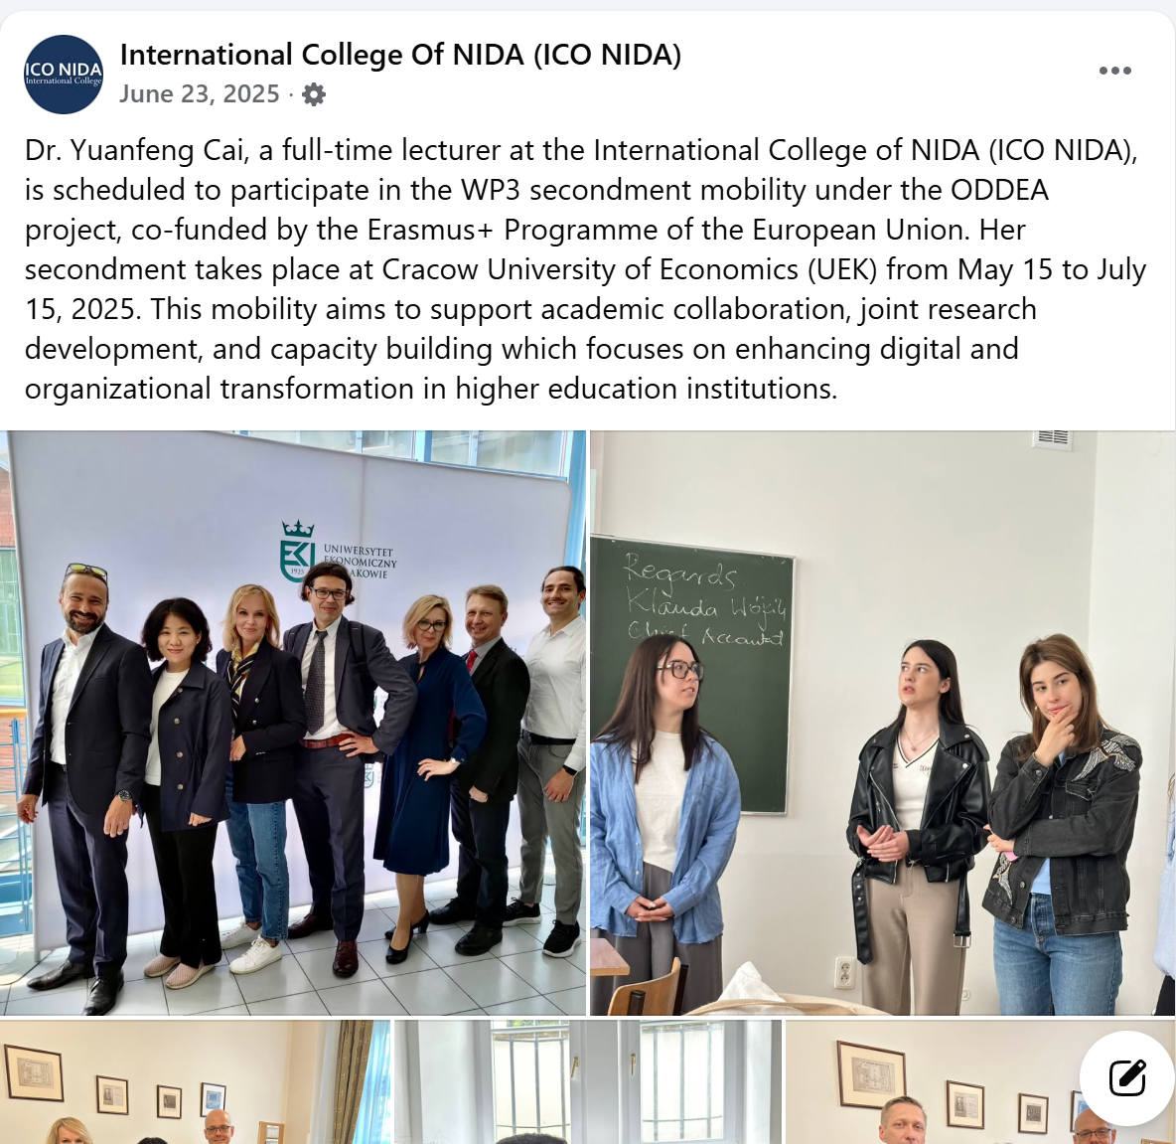

Feb 13 2025
Prof Zoltan and Prof Papp
https://www.facebook.com/share/p/1AQ9tF9tDr/
