Dissemination report

Date: 2 June 2026
Venue: UiTM
Organizing/Host institution: UiTM
Sending institution: SIU

Description:

ODDEA Researcher Contributes as International Jury at AiCoBM 2026
As part of his research secondment at Universiti Teknologi MARA (UiTM) under the ODDEA (Overcoming Digital Divide in Europe and Southeast Asia) project, Mr. Andras Aschenbrenner, a doctoral candidate from Széchenyi István University (SIU), Hungary, participated as an international jury member during the AAGBS International Conference on Business and Management (AiCoBM) 2026, held on 2–3 July 2026 at the Arshad Ayub Graduate Business School (AAGBS), UiTM Shah Alam.
On 2 July, Mr. Aschenbrenner served as one of the judges for the Innovation, Invention and Design (IID) Poster Competition, where MBA students showcased innovative ideas and research projects. His participation provided an international perspective in the evaluation process while exposing students to global academic standards and constructive feedback.
Beyond the judging session, the event created valuable opportunities for Mr. Aschenbrenner to engage with UiTM students and academic staff. These interactions facilitated meaningful exchanges of ideas, discussions on current research interests, and networking between researchers from UiTM and SIU. Such engagements are central to the objectives of the Horizon Europe Marie Skłodowska-Curie Actions (MSCA) Staff Exchanges programme, which promotes international collaboration, knowledge sharing, capacity building, and the development of sustainable institutional partnerships.
The participation of seconded researchers in institutional academic activities such as AiCoBM 2026 demonstrates how the ODDEA project extends beyond research implementation by strengthening academic linkages, encouraging future collaborative research initiatives, and enhancing the internationalisation agenda of both UiTM and its European partner institutions.

Photos:

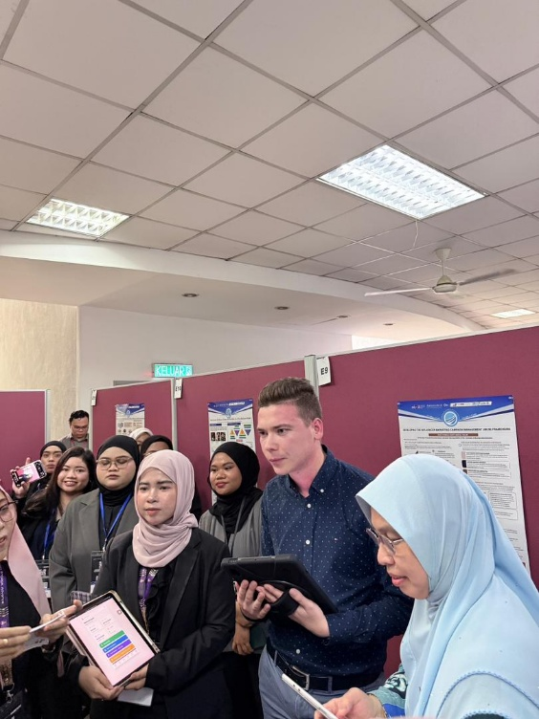

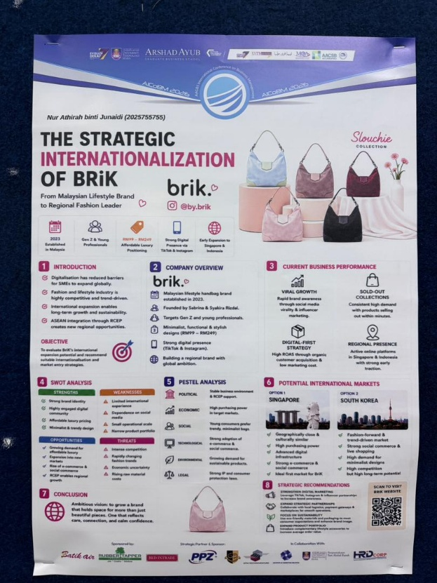
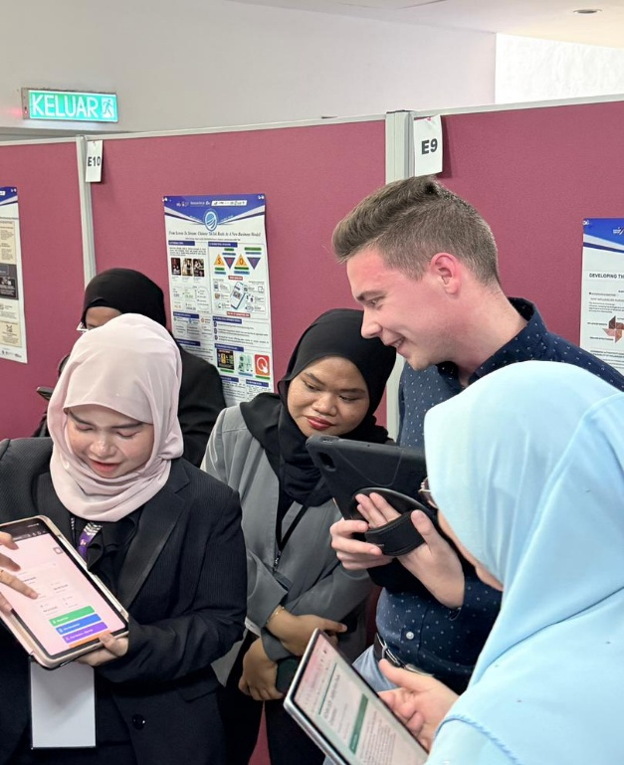

Report prepared by: Assoc. Prof. Dr Azlina Hanif, UiTM

