Dissemination report

Date: December 2025 – January 2026
Venue: Arshad Ayub Graduate Business School, UiTM
Organizing institution: UiTM
Description:
ODDEA Secondment Mobility at UiTM (December 2025 – January 2026)
As part of the ongoing dissemination and mobility activities under the Horizon Europe MSCA Staff Exchange project Overcoming the Digital Divide in Europe and Southeast Asia (ODDEA), Universiti Teknologi MARA (UiTM) hosted two Experienced Researchers from Széchenyi István University (SIU), Hungary, during the period December 2025 to January 2026. The incoming researchers were Assistant Professor Dr. Barbara Huszár and Associate Professor Dr. Ferenc Darabos, both attached to Work Package 4 (WP4) of the ODDEA project.
Prior to their arrival at UiTM, both researchers conducted data collection activities in Hungary in line with the objectives of WP4. They subsequently spent a two-month secondment period at UiTM, engaging closely with the UiTM ODDEA research team. This mobility enabled in-depth research discussions, methodological exchanges, and further refinement of empirical analysis, strengthening cross-institutional collaboration between SIU and UiTM.
The outcomes and preliminary research findings from this collaborative work were disseminated through a dedicated knowledge-sharing session held at Arshad Ayub Graduate Business School (AAGBS), UiTM. The session provided a platform for academic staff and postgraduate students to engage with the research, exchange feedback, and discuss policy-relevant implications related to digitalisation, innovation, and inclusive development - key themes underpinning the ODDEA project
In addition to research-focused activities, Dr. Barbara Huszár also attended a marketing guest lecture jointly hosted by the Institute of Marketing Malaysia (IMM) and AAGBS UiTM, further enhancing academic-industry exposure during the secondment. The guest lecture facilitated professional networking and interdisciplinary exchange, during which Dr. Huszár met Professor Ruth P. Stevens from NYU Stern School of Business, New York contributing to broader engagement beyond the immediate research scope of WP4.
Overall, the secondment mobility reinforced the objectives of the ODDEA project by promoting international research collaboration, knowledge transfer, and capacity building between European and Southeast Asian partners. The engagement at UiTM not only advanced the progress of Work Package 4 but also strengthened institutional ties and laid the groundwork for future joint research, dissemination, and academic networking activities under the ODDEA framework.
Photos:
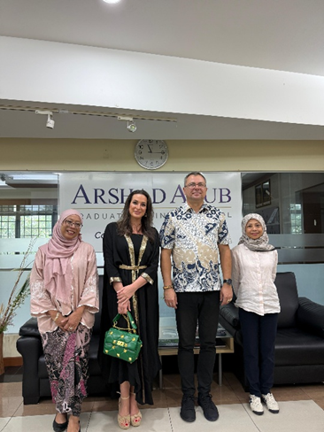
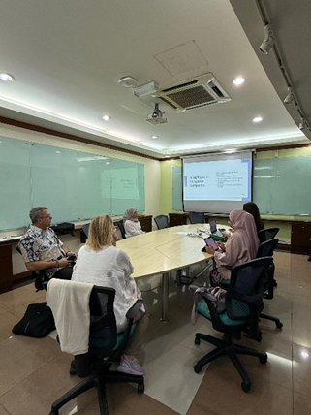

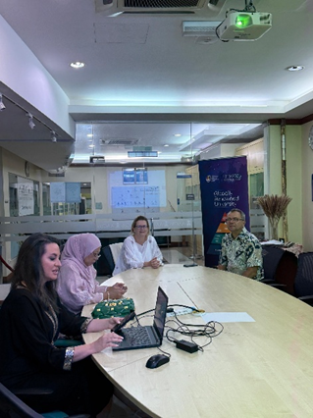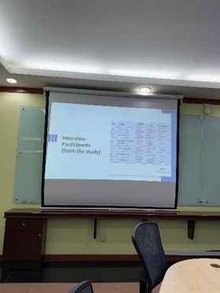
Sessions with Dr Barbara and Dr Ferenc

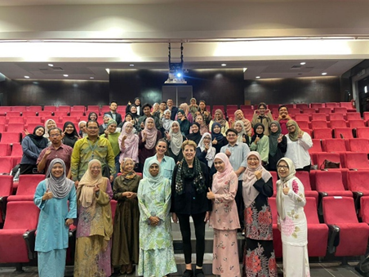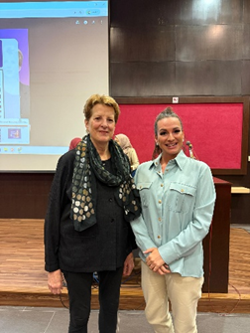
Dr Barbara Huszár attending the guest lecture by Prof Ruth P Stevens

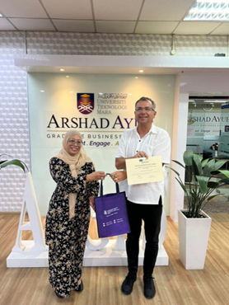
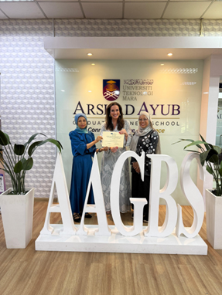
Presentation of the certificate of participation in ODDEA
Report prepared by: Associate Professor Dr Azlina Hanif, UiTM

