Dissemination report

Date: July-August 2025
Venue: Arshad Ayub Graduate Business School, UiTM
Organizing institution: UiTM
Description:
As part of the Horizon MSCA Staff Exchange project “Overcoming the Digital Divide in Europe and Southeast Asia (ODDEA)”, Universiti Teknologi MARA (UiTM) hosted Dr Sylwia Kruk from Krakow University of Economics (UEK) for a one-month research secondment in July 2025. Dr Kruk’s mobility was conducted under Work Package 3, focusing on research activities aligned with the project’s objectives.
During her secondment, Dr Kruk actively engaged with UiTM’s academic community and presented her research progress and preliminary findings to faculty members and postgraduate students. The session provided a valuable platform for scholarly exchange, constructive feedback, and discussion on the role of digitalization, institutions, and market structures in addressing the digital divide across Europe and Southeast Asia.
In the same period, the ODDEA project coordinator, Professor Dr Anetta Caplánová, and Associate Professor Dr Lubomír Darmo from University of Economics in Bratislava (EUBA) also visited UiTM to discuss matters related to project implementation and progress. Professor Caplánová paid a courtesy visit to the Dean of the Arshad Ayub Graduate Business School (AAGBS), Professor Dr Norzanah Mat Nor, followed by a working meeting with the UiTM ODDEA research team comprising Associate Professor Dr Azlina Hanif, Associate Professor Dr Arlinah Abd Rashid, Professor Dr Tan Peck Leong, and Associate Professor Dr Nor Irvoni Mohd Ishar.
The discussion centred on the overall progress of the ODDEA project, research outputs to date, coordination across work packages, and forthcoming tasks and deliverables. The meeting also reinforced collaborative strategies to ensure the successful achievement of project milestones and the effective dissemination of research outcomes.
These engagements reflect the strong commitment of UiTM and its European partners to fostering high-quality research collaboration, knowledge exchange, and capacity building under the Horizon MSCA framework. The research mobility and project meetings not only strengthened institutional ties between Southeast Asia and Europe but also contributed meaningfully to advancing evidence-based insights on bridging the digital divide across regions.
Photos:
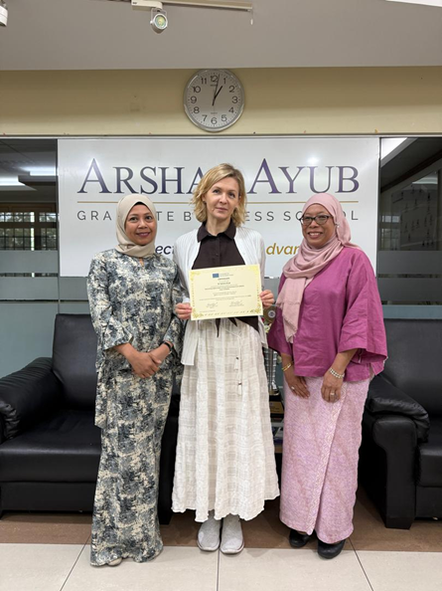

Dr Sylwia Kruk with Associate Professor Dr Azlina Hanif and Associate Professor Dr Arlinah Abd Rashid

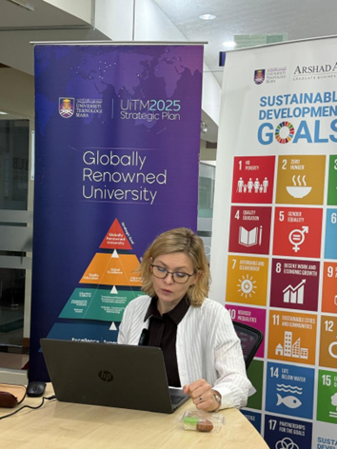
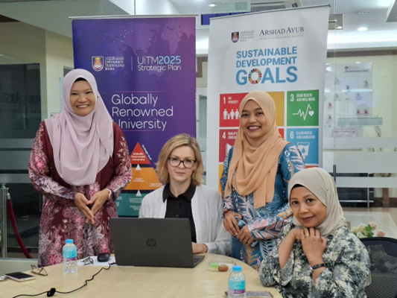
Knowledge Sharing Session with Dr Sylwia Kruk

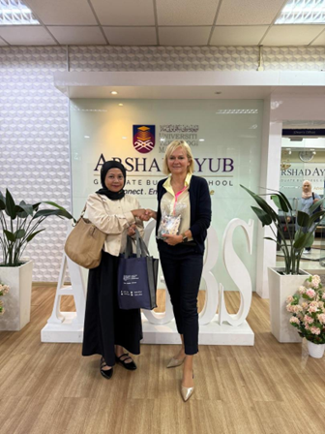

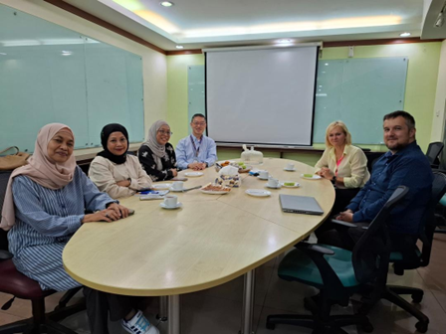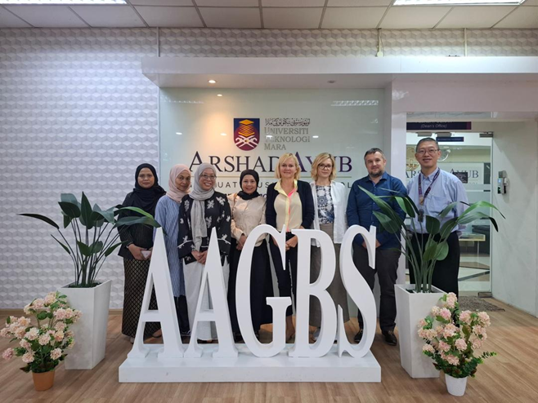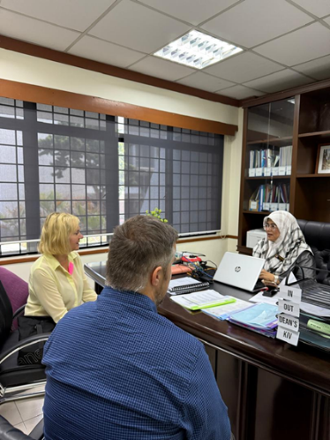

Professor Dr Anetta Caplánová’s visit to AAGBS, UiTM

Report prepared by: Associate Professor Dr Azlina Hanif, UiTM

